OCR GCE A
COMPUTER SCIENCE PROJECT
H446-03

Name: Saleh Faiz
Candidate Number: <INSERT CANDIDATE NUMBER>
RR6: <INSERT CENTRE NUMBER>
Title of Project: Tomb of the Mask

H446-03 – PROJECT CONTENTS
Table of Contents
Section A. Analysis 2
Problem definition 3
COMPUTATIONAL Methods 4
Thinking Abstractedly 4
Thinking procedurally 5
Proformance Modelling: 7
Thinking Logically: 7
Selection 7
Iteration 8
Sequence 8
Thinking Concurrently 8
STAKEHOLDERS 9
Initial stakeholder 9
Additional stakeholders: 10
Overall stakeholder conclusion 11
Research of existing solutions and Essential features 11
Continuous directional movement until collision 12
Stakeholder feedback – ABOUT CONTINUOUS Directional MOVEMENT UNTIL collision 16
Procedural generation 18
User interface and sound effect 19
Moster chancing the player 20
user Data storage and leaderboard 21
Stakeholder analysis of leaderboard feature 22
PREEXISTING VERSION OF Tomb of the mask 25

GAMES similar to TOMB OF THE MASK 25
Donkey Kong 26
Minecraft Dungeons 28
Limitations 29
Online access 29
Unique levels 30
Keyboard CONTROLS instead of swiping 30
GRAPHICAL AND ART LIMITATSIONS 30
Hardware and software requirements 31
Hardware 31
software 33
Success criteria 34
Section B. Design 40
Introduction and overview 40
Problem decomposition 41
STRUCTURE OF THE SOLUTION & breakdown of induvial sections 43
User Interface 43
Leaderboard GUI design 44
Player Score 47
Options/settings menu design 47
Overall button class and functionality 53
Useability Features 56
GAME Tutorial 56
Pausing the Game 58
GUI layout 59
KEY VARIABLEs 60
iterative development test plans 62

POST DEVELOPEMENT TEST PLANS 63
Leaderboard and database 65
Database structure 66
Leaderboard data collection 68
Writing players high scores to database and searching database 70
Loging player in and registering new players 70
Test Plans – for database functionality/ leaderboard integration 72
KEY VARIABLES For database and leaderboard 75
Player mechanics 76
PROCEDURAL Generation 76
Overview 76
Map design 78
Tile set 79
Spawn segment 80
level segments 81
TRANSISTION SEGMENTS 82
Locating specific tiles and objects from the map file 83
WALL AND SPIKE TILES 83
Coin Tiles 85
Spawn Tiles 86
Generate ZONES 87
Camera scrolling 88
Rising lava or Chasing monster 88
Lava mechanics 89
Section C. Developing the coded solution (“The development story”) 90
Menu system 90
Super class 90

labels 91
Buttons 92
Rendering 93
Hovering 94
Clicking and button functions 96
MENU CLASS And structure of code 98
Creating menu objects and UI objects and testing buttons 100
Main menu 101
Bug with changing BETWEEN IN Game pause menu and main menu 106
Database connection and leaderboard 109
Map creation 111
PLAYER MECHANICS 111
Bug with game not restarting upon player death 111
Section D. Evaluation 114

Section A. Analysis
PROBLEM DEFINITION
Using Python 3.11, I plan to develop a desktop version of the arcade style mobile game “Tomb of the Mask” which is a popular mobile game released in 2018 with over 500 million downloads worldwide. The reason I have chosen to create this game is because it was a core aspect of my childhood and I want to honor it by creating a replica and paying tribute to something that shaped me as a person. In recent years however, the game has been monetary focused; jamming the screen full of ads and forcing paid promotions down the user's throat. Upon revisiting this game recently, seeing this dramatic change was a true shock. By creating this implementation, I am taking the game back to its roots, bringing back the Tomb of the Mask I know. Reliving my childhood. This problem is not isolated for me. Other players are experiencing this same feeling of disconnection from the game's core focus.
Therefore, by creating this I am not only helping myself, but also all the people like me who want to unlock an old memory from their childhood.
In the game, the user controls a character known as an “Agent.” He must traverse through a vertical labyrinth riddle with a variety of obstacles including spikes and bats which the player must avoid.
The user controls the Agent by a process of continuous directional movement until collision. Due to this unique movement mechanic, the player is forced to navigate through the labyrinth with caution as one wrong swipe could send the Agent flying across the map into a wall of spikes forcing them to reset the level. The player must therefore manage to move and position the Agent in such a way as to reach the end of the level, marked with a door, and collect coins, stars and power-ups scattered throughout the level. If all the stars are not collected, the door will not open, thus not allowing the agent to process. The power-ups provide advantages such as a temporary shield or increased speed. Upon completing the level, the user can spend his/her hard-earned coins in the shop to purchase cosmetic items, such as skins, before progressing onto the next level increasing in difficulty. Below are
screen shots of the original version of the game “Tomb of the Mask” illustrating the construct of the levels and overall style of the game:
Figure 1.1:
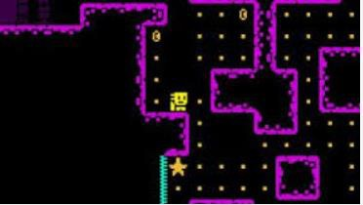

Figure 1.1 shows the “Agent” in the labyrinth. Coins are represented as oval shaped objects with a black indent. Two are shown in this image. The yellow squares shown throughout the level indicate the recommended path for the player to move the Agent along. Also shown is a Star. The level’s difficulty is measured upon how many stars the Agent must collect to proceed to the next level. Finaly, on the bottom of the screen is a spike wall shown in light blue.
COMPUTATIONAL METHODS
Creating this game provides a unique opportunity to use a wide range of computational methods. Listed below are examples and explanations of all the different computational methods I will be using to create this game, along with why I believe them to be crucial in leading to an effective approach in the game’s development. I need to approach this project computationally as it is better suited as being a video game rather than a board game or some other non-computer-based game because of the various moving parts and animation that are required for the use to expire the full capability of the game.
Moreover, the game was initially created as a computer-based game and not as a non-computer-based game.

THINKING ABSTRACTEDLY:
I will be using abstraction various times throughout the implication of this game to reduce its complexity and the time it takes to complete. This is because the base game was developed by a large group of people over several years. I will now explain all the situations where I intend to use abstraction and why it will help below:
- The original version of the game has thousands of hand-crafted levels with more coming out every week, all with unique features and problems for the player to solve. This was important for the original game because it kept the players anticipating a new level which led to longer player retention. However, for my implication of this game I will not be using levels. Instead, I will focus on the “arcade” version of the game where there is only one endless procedurally generated map where the player is scored based on how far he/she progresses vertically upwards through the map. I believe that this will reduce the overall complexity of the game and thus increase the time I can spend on game mechanics and not on designing the levels. Moreover, if I were to implement a level mode, I would thus also have to create a level designing feature to create each level uniquely. This would therefore add a great deal of space complexity to the product, which would reduce its playability on lower-end machines.

- I also plan to use abstraction on the range of power-ups available to the player. In the original version of “Tomb of the Mask” there are a wide range of power-ups scattered throughout the map such as: “Coin Addict,” “Freeze,” “Magnet,” “Shield” and “Score Booster.” Each of these power-ups lead to a diversified experience when playing the game. However, in practice implementing all these will increase the game's complexity and the overall time it takes to
complete. Therefore, for my version I will only be using the “Score Booster” and “Shield” power-ups each of which I will explain extensively in the design part of this project.

- Finally, I will reduce the overall complexity of the Art and character design/animation to a much more minimalistic and standard version. This will not only reduce the overall space complexity of the game but also allow me to focus more on game development rather than on graphic design.

THINKING PROCEDURALLY:
This project lends itself very favorably to thinking procedurally, especially to decomposition as each part and aspect of the game can be decomposed into individual smaller sub-tasks. Below is a very simple workflow diagram illustrating how I will approach the game’s development using decomposition.
Diagrams like this will be in more depth in the design section of this document.

Figure 1.2:

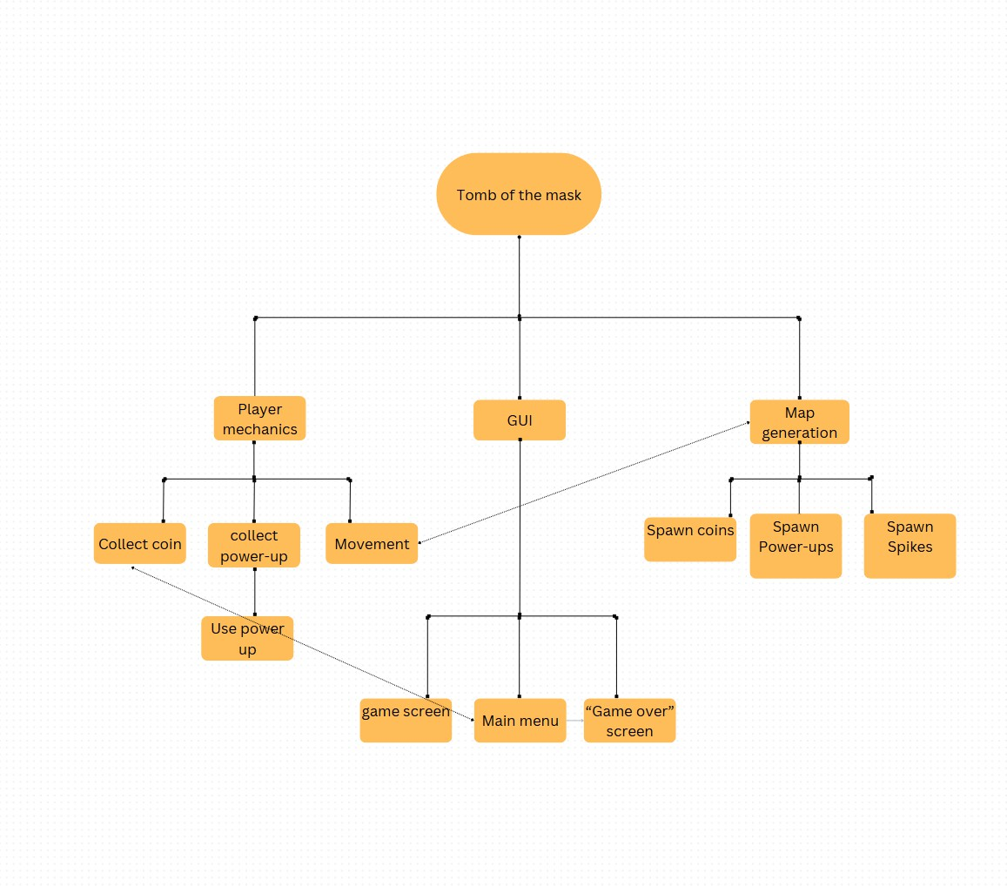
In Figure 1.2 the order of hierarchy is shown as a solid bold line leading from one square to the next. Interactions are shown as dashed lines. For example, from movement to map generation, the map will generate based on how the player moves.
I will also be thinking procedurally by breaking each part of these problems illustrated above into different procedures and functions and classes. Object-oriented programing (OOP) will play a crucial role in this as well.
For the development of my game, I will use OOP. This will streamline the development process by allowing me to model each aspect of the game as individual objects. These objects can interact with each other in a structured manner, making the code more maintainable, modular, and reusable.
For example, I plan to create a Player class that encapsulates the player's attributes and behaviors, such as movement, collision detection, and the player's score. Other objects, such as Enemies or Obstacles, can then interact with the Player object to handle events like collisions or game logic. This approach ensures that the code remains organized and scalable as new features are added.

Additionally, OOP allows me to effectively implement various programming constructs such as selection and iteration. Selection will be used in Decision-making, as many interactions between objects will require conditional logic, such as determining whether the player collides with a spike or collects a coin,

PROFORMANCE MODELLING:
Throughout this project, I plan to model several core game mechanics individually before integrating them into the main game. For example, I will model the player's movement in a separate Python script by simulating an object moving between a series of predefined walls. Once this model is functional, I will transfer the code into the main game script. This allows me to focus on refining key features independently, without being affected by dependencies within the full game, such as map generation relying on movement, as depicted in Figure 1.2 above. This approach is therefore expected to reduce the overall time spent on each mechanic by minimizing troubleshooting during integration.
However, one potential challenge is that a mechanic working in isolation may encounter compatibility issues when incorporated into the complete game due to unforeseen interactions. To mitigate this, I will test mechanics with placeholder systems and document dependencies to ensure smoother integration.

THINKING LOGICALLY:

To think logically, I will approach the design and testing section in a systematic and logical way using techniques such as abstraction, decomposition, and algorithmic thinking. For example, in the design section I will approach each fundamental feature of the game in a logical manner. This means that I will not try to solve a problem in large chunks but instead in small and easier to comprehend ways by using decomposition. I will do this by using IF and ELSE statements in flow charts to streamline the thinking process and thus have a set algorithm in which I can follow in the development of the game. These are examples of “structural programing techniques”. I will now illustrate how I will use each structural programing technique:
SELECTION

Selection is the process when an algorithm/computer must decide between different outcomes, this is done using IF, ELIF, and ELSE statements to change how the program behaves depending on the condition of the player (or any other object/ conditions) in that state. In my game, I will most definitely be using selection to dictate how the program behaves. For example, if the user is to turn left down a maze, then the program must generate a certain value. However, if they are to turn right then a different value must be generated. The value to be generated then must be decided and dependent on

the direction the user turns. To handle this, selection must be used, otherwise, how will the program know what value to generate?

ITERATION
Another vital aspect of thinking logically is iteration. Iteration is the act of repeating through a set block of code several times. There are two types of iteration, both of which I plan to use in my project, that dictate the number of times they repeat. The first is condition-controlled iteration which involves repeating a line of code until a certain condition is met. For example, while loops that repeat until a condition is true. I will use these when there is an indefinite and uncertain number of times that the set block of code needs to be repeated. This may happen in situations such as continuous directional movement until collision, because there will be an unknown number of pixels that will need to be traveled by the player until it hits the wall. Therefore, as there is a condition that must be met before the code is stopped repeating, a condition-controlled loop must be used. The second type of iteration is a count-controlled loop. This is when the set block of code is looped through a fixed, and given, number of times. This can be used when iterating through a database to find user information. This can be used because there will always be a fixed number of users in the database in which each item in the database can be processed individually.
SEQUENCE
The final aspect of thinking logically is Sequence. This is the process of sequentially executing each line of code one by one as they are needed. This will be used in many aspects of my game and predominantly in the use of functions and procedures. I will use functions and procedures as they are reusable blocks of code that can be called in the main execution of the program as they are needed. This is important, as it will allow me to execute, for example, each step of maze generation as they happen in real time.
THINKING CONCURRENTLY:

To ensure the efficient and timely completion of this project, I will employ the principle of concurrence throughout its development process. By strategically queueing or scheduling tasks to align with and feed into the preceding ones, I aim to create a seamless workflow that minimizes downtime between task transitions. This approach will significantly reduce instances of procrastination or delays that often occur when moving from one phase to another. Instead of facing disruptions or idle periods, each task will naturally lead into the next, fostering a continuous momentum that keeps the project advancing steadily.
Moreover, by integrating concurrence as a core methodology, I can enhance the overall coordination and synchronization of activities. This systematic alignment allows me to anticipate dependencies and allocate resources more effectively, ensuring that the groundwork for subsequent tasks is already prepared in advance. Consequently, this proactive strategy not only saves valuable time but also optimizes productivity and resource utilization throughout the project's lifecycle.

STAKEHOLDERS
For my project, Tomb of the Mask, I will be targeting a wide demographic of people, as the game is geared towards the younger generations, people below the age of 18. I believe this to be the most efficient way to gather a deeper understanding of how I can improve the game throughout the development process and tweak features to make it more enjoyable for the average player. However, the mindset and motivations of a 17-year-old and a 10-year-old are vastly different and will lead to a discrepancy in the way the game develops; a 17-year-old may want more action while the 10-year-old may want brighter coloured backgrounds and/or sprites with simpler controls. Moreover, there may be a gender bias if all stakeholders are chosen from the same gender. The game should be accessible and playable for all people.

INITIAL STAKEHOLDER
To achieve this, I have chosen two stakeholders: a 17-year-old male friend, an avid PC gamer with insights on the arcade genre, and my 9-year-old sister, who frequently plays mobile games on her iPad. Their differing perspectives will help me create a balanced game that appeals to both demographics. By incorporating their feedback, I can ensure the final product is engaging, accessible, and enjoyable for a diverse audience.
Throughout the process, my stakeholders will provide regular feedback on the game's features and set the general trends for its development. Likewise, before I implement a new feature, I will discuss at length the drawbacks and positives of every new feature with them. But before the development begins it is critical that I have a baseline, a template, for the game's roots. This means I will conduct a small interview with each stakeholder individually to assess the direction I want to progress the game towards. Below is the transcript of the interview I conducted with both of my stakeholders individually. I will be asking the stakeholders that same questions so to consolidate their answers below I will denote the replies from my sister as “QF” and the replied from my classmate as “QM.” Proceeding the interview, I will summarize the answers given and address problems that have arisen.

Transcripts 1.1:

Q: “Have you ever played the mobile game tomb of the mask before and if so, what was your
experience of it?”

AF: “Ya, I used to play that with my friend. It’s really fun.”
AM: “When I was younger, I played it, but I got really bored of it because there are way too many ads and pop-up."

Q: "What was, in your opinion, the best part of the game?"
AF: “I really liked the colour and the different guys you can collect” - By guys she means skins
AM: “Definitely the movement was the best part, it felt really unique, and I don't know of any other game that has the same feature.”

Q: “Was there any features of the game that you particularly disliked and would want removed or changed?”
AF: “I don’t really know. I quite liked it but the some of the levels were really hard Could you make an easier one?”
AM: “Ya, as I said before the ads are really annoying and I found some of the levels really easy.”

END TRANSCRIPT

Transcript 1.1 summary:
As predicted, the two stakeholders have very contrasting views due to their different ages and outlooks on life. Where the 9-year-old wanted easier levels, the teenager wanted harder levels. At first, this may seem like a Hulting problem because of the duplicity of these two requests. However, it is the opposite and has provided me with valuable insights that will lead to a more fun game. From this therefore, I have concluded that there will be a difficulty scaler in the procedurally generated part of the map. (I will be discussing this in more detail in the design aspect of this report.)
Moreover, another key takeaway is the abundance of ads and pop-ups. This is easy to solve as there were never any ads planned to be in my instance of the game. The original game had to include these, however due to the necessity of monetisation for a large game studio.

ADDITIONAL STAKEHOLDERS:

While these two people are a vital aspect of my game’s development, it will also be important later that I can gather a larger sample to create a more representative view. To solve this, before each new feature is added I will conduct a larger and broader questionnaire target to give me generalised feedback on said feature. This will typically be around 10-15 people, and each question will be answered by either yes or no or similar one-word answers. Following this I can create a small table highlighting their responses to demonstrate any trends and patterns that emerge from their responses.
Each survey will be conducted manually by me, and each participant will be a member of my A-level computer science class. While this may not be completely accurate to the whole demographic of people who will be playing the game, it will be close enough to gather a general idea about trends. Any more specific details for target demographics will be discussed by the two individual/initial stakeholders outlined in the section above titled “Initial stakeholders.”

OVERALL STAKEHOLDER CONCLUSION
Overall, following all the questionnaires and interviews with my stakeholders, (some of which proceed in the “Research of existing solution and essential features” section of this document) it has been concluded that the following areas are important to my stakeholders, and this should be made a priority when developing it:
. The game must be competitive as to create a sense of purpose when playing, without being over competitive as to lose to the sense of joy when playing. 93% of stakeholders believe that this can be created sufficiently by using a leaderboard in which player can compare their stats to other players. Therefore, to create competition and thus a sense of purpose in the game a leaderboard will be implemented.
. The game should reliably implement continuous directional movement until collision as determined by 70% of my stakeholders to be a vastly important feature of the game which would make it not feel like Tomb of the Mask without.
. The game shouldn't have ads or pop-ups as this takes away from the core aspect of the game and makes it feel cheap and insincere. This is not a a problem and will be easy to implement as I don't have to change anything as there, we never intended to be ads in the first place.
By following my stakeholders' inputs, I can hopefully implement a game that is more closely aligned to their ideas on how the game should be created and what they would want to see out of it. It there therefore lead to a better and more playable implementation of the game.

RESEARCH OF EXISTING SOLUTIONS AND ESSENTIAL FEATURES

I will now illustrate existing solutions that exhibit similar mechanisms to features that I will implement in my game and explain each essential feature and why I will be implementing them. This will also be followed with stakeholder feedback about these features and why they are important to the game.

CONTINUOUS DIRECTIONAL MOVEMENT UNTIL COLLISION:
The feature of continuous directional movement until collision is unique to tomb of the mask in their implementation of it. However, they are not the first game to use this mechanic, only the first game to use it in the realm of a platformer. The term continuous directional movement until collision is a term used to describe how the agent will move through the maze. It means that the user will impot one movement command (for example arrow key left) and they will move in that direction continually until they collide with something (say a wall) that stops their movement. This means that when the user presses a key the agent's direction cannot be changed until it has collided with something that stopes its movement. In this sense the movement is continuous, in one of the cardinal directions and repeats until collision, thus leading to the name continuous directional movement until collision.
An example of this mechanic being used in other games is in the popular puzzle game 2048. Here, the player moves “blocks” corresponding to different numbers from left to right. When the block collides with another block, the sum of the two block’s corresponding number is mapped to a new block at the place of collision. Below are annotated pictures showing the process of this mechanism happening as the player swipes left over 3 turns.

Figure 1.3

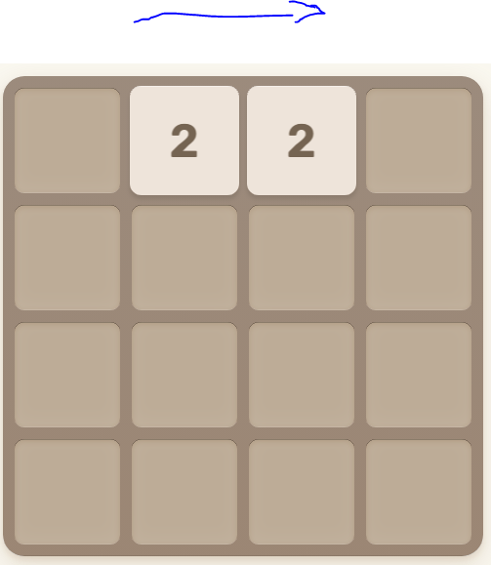

Figure 1.3 shows how the board spawns upon opening the game. From this, the player swipes left, and both blocks move to the furthest corner until they collide with a wall. Once they reach this wall a new block appears with the sum of the 2 blocks at the far corner, “4”.

Figure 1.4

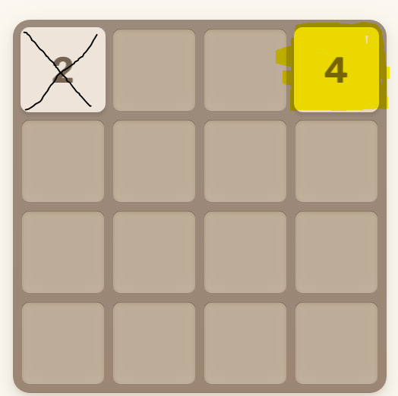

Upon swiping left, both blocks move as far left as they can before colliding an object. In addition, a new block “2” appears. This is irrelevant to the movement mechanism and is crossed out in Figure 1.4 to avoid confusion. Observe only the highlighted box which is the resultant position of the combined 2 blocks.

Figure 1.5

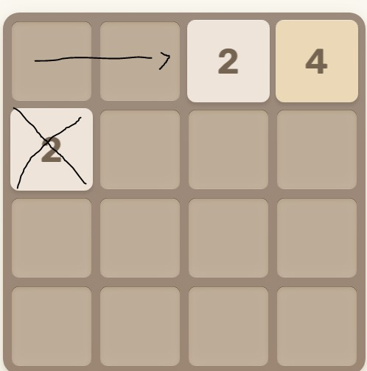

Figure 1.5 shows another swipe to the left proceeding the events observed in figure 1.4. Again, observe how block “2” moved from the far-right corner to the farthest left corner until it collided with block 4. The arrow shows the direction of the “swipe” and the newly appeared “2” block is crossed out to avoid confusion.

Analysis of solution:
This game perfectly highlights the mechanism of continuous movement until collision and will help me better implement it in my game. Whilst this is like the movement system in Tomb of the mask it differs in the way that each block moves in relation to each other and thus the movement is not individualised to each block like it will be in my implementation. Therefore, beside this minor difference 2048 demonstrates perfectly how I wish to implement the movement mechanism in my game.

Alternate solution
Another game that implements a feature similar to continues directional movement until collision is Snake. In this game, the player controls a snake around the screen positioning it in such a way to collect the apples scattered throughout the map. In this game, the user can only move in the 4-cardinal direction and will continue to move in that direction until the player presses another direction key

(WASD) or collides with the wall (where the snake dies.) In this way, it is exactly continuous directional movement however negating the collision part as if the player is to collide with a wall they will die instead of being able to change direction. The screenshot from the game below (taken from google snake) shows how this mechanism works in this game.
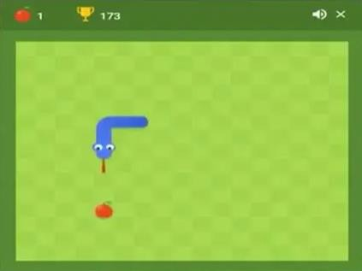
The screenshot above shows a still frame capture of the game. It is important to note that in the real game, the snake is not stationary and cannot become stationary at any point while running. Instead, in this screenshot, the snake will be moving downwards at a constant velocity and will continue to move in that direction and speed until the player inputs a key (WAD) - inputting S will not change the direction as it is already traveling downwards – at which point it will begin traveling in the direction corresponding to the key pressed. For example, if the key A is pressed, the snake will travel to the left and if D is pressed it will travel to the right. It will then not stop moving in that direction until another key is pressed.
This is like Tomb of the Mask because in it the agent will travel only in the direction in which the player presses and will not stop moving in that direction until it collides with a wall and another key is pressed. However, they differ in the sense that in Snake the player is free to change direction at any time while running whereas in TOTM the user can only change direction if they are stopped by running into a wall. This is also another difference. In Snake, the player cannot ever stop moving whereas in Tomb of the Mask they must in order to change direction.

STAKEHOLDER FEEDBACK – ABOUT CONTINUOUS DIRECTIONAL MOVEMENT UNTIL COLLISION
It is important to both me and my stakeholders that we have this movement mechanism due to it being an intrinsic aspect of the game. In this sense, it would not be Tomb of the mask with this unique feature.
The following table shows the results to the question:
“Do you believe the feature of continuous direction movement until collision is important to tomb of the
mask?”

Chart 1.1

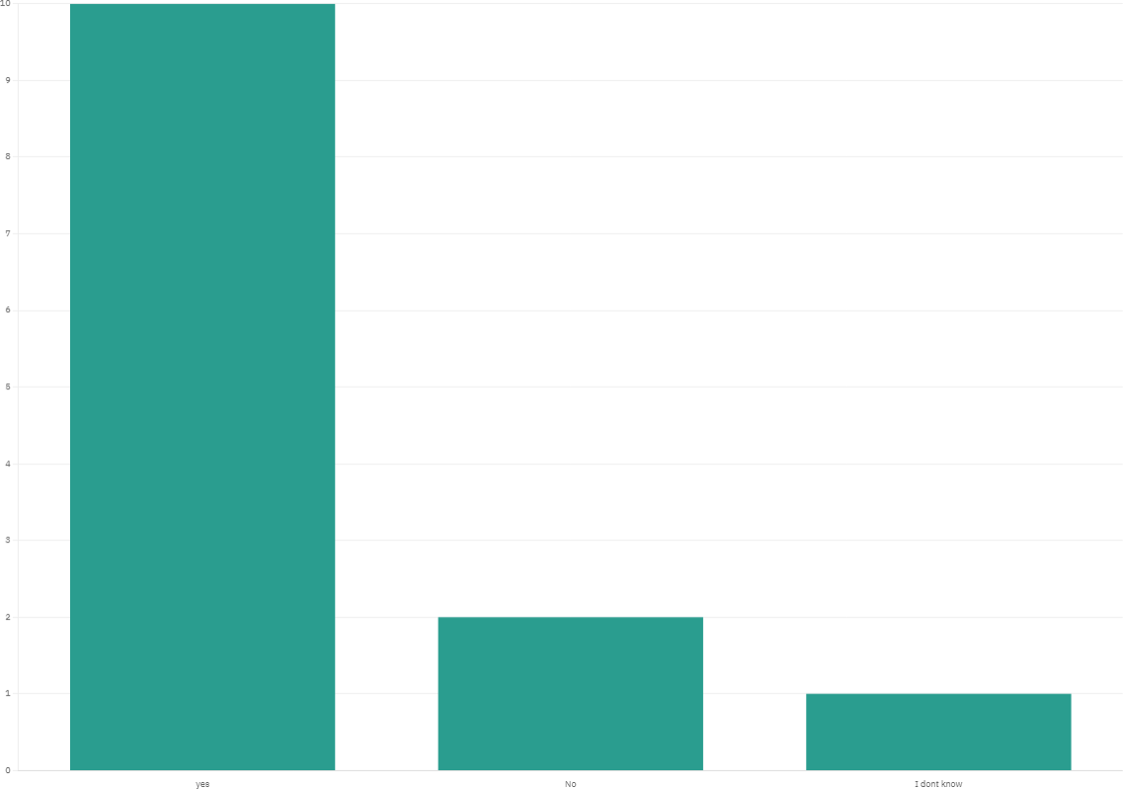

Chart 1.1 shows that:
- 10 people said “yes”
- 3 people said “no”
- 1 person said “I don't know”

Overall, highlighting the importance of this feature, a majority of the 14 stakeholders agreed that it is an important and essential feature. I will therefore be making continuous directional movements until collision a core feature of the game.

PROCEDURAL GENERATION
Procedural generation is a key aspect of many games with a wide array of games using it to generate their maps. One example of this is the popular computer game Minecraft. Minecraft uses Perlin Noise to generate “seeds” which is a key to randomness. This allows there to be random generation with an outlined set of protocols to follow. In this way, a random map can be generated without breaking the constraints of the game. For example, in Minecraft, a random seed is generated while following specific terrain rules such as water not spawning in the air and a tree not spawning on stone, only on grass.
These protocols are essential to the continuity of the game and the user experience.
I will need to follow these rules when generating the map for my own game. For example, there will need to be rules in place dictating where spikes and stars can generate. Therefore, I will be using a similar procedural generation algorithm to that of Minecraft. To ensure that this works, I will first be developing this in isolation (performance modelling). This will be discussed in further detail in the development section of this document.
Below is an example of a procedurally generated maze with enemies spawning randomly throughout the mase. This is like how I will implement this feature in my game and thus perfectly demonstrates the feature. Observe how there are patterns that are followed by the algorithm that dictates where things can spawn, such as the red circles are not spawning inside the walls. This will be a fundamental problem that I will need to solve when implementing this feature.

Figure 1.6

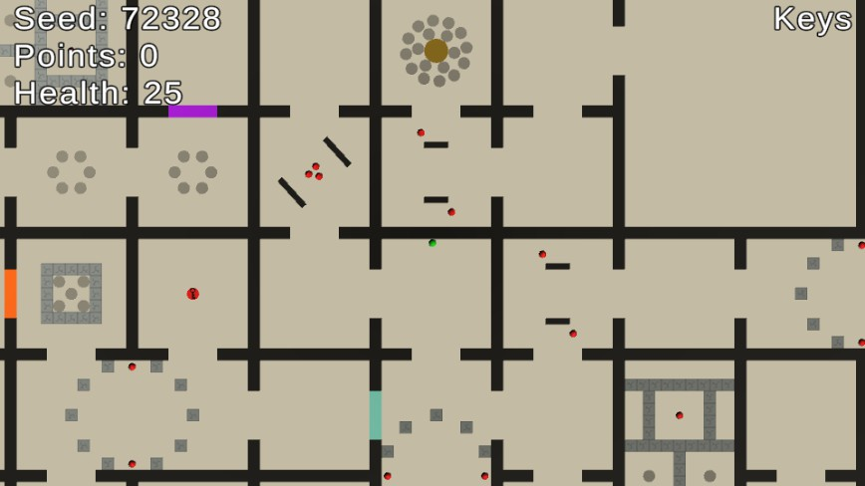

The reason this feature is essential is because it will allow the game to feel unique each time the player plays. This will increase player engagement and allow for a more authentic game experience. The other solution to this problem would be set, hand created levels. This would not only be a waste of time for me due to the tedious process of hand making each level but also lead to a limited game play experience. This is because theoretically a procedurally generated game can last forever while hand crafted levels are finite. However, the upside to hand crafted levels is that they may be more detailed and in depth.
The original version of Tomb of the mask has two different modes. In one mode, there are a set number of levels that were handcrafted by the development team who created the game. In the other mode, there is an infinite generated maze which the player traverses called “Arcade mode.” As I have mentioned before and will continue to mention again in more detail in later sections, I will be implementing only the Arcade version for a verity of reasons. Therefore, the only solution to the generation is procedural generation.

USER INTERFACE AND SOUND EFFECT
The user interface and sound systems are undoubtably vital features of any game. They are the main thing that people will judge a game on upon first playing. This is why, to create a good first impression

and keep player engagement, the user interface and sound effects must be thoroughly thought out and perfectly constructed.
Many games, including the original issue of Tomb of the Mask, use brightly coloured user interfaces to appeal to a younger audience. There have been many physiologic study's behind why this is the case demonstrating why games like this should implement a bright and colourful colour scheme. Therefore, the colour pallet for my game will consist of bright colours that “pop” out of the screen. The user interface will also have to be easily navigated and well labelled. For this, I will choose a minimalistic approach to the UI available to the user. The design of this and implementation of this will be discussed in more depth in the design section of this document.
The sound system will also be following this minimalistic approach as to reduce time being wasted on sound development and to reduce unnecessary complications arising.
MOSTER CHANCING THE PLAYER

In the innitial version of Tomb of the Mask, the user was chased by “lava” which rose at an accelerating rate preventing the agent from traversing back upon himself and giving them a time limit to complete the level/zone as, if the player where to touch the lava they would die. This also gave the levels a sense of difficulty because as the level progressed the lava would rise at a faster rate making it harder for them to complete said level.
This worked on the original version because the game was meant to be played on phones rather than desktops where most of the labyrinthine existed vertically above the player, and as the lava rose vertically it gave players enough time to escape it per level/zone. However, in my version, the game will be played horizontally as it is meant for desktop users where most of the labyrinth exists horizontally. This is because the dimensions of the game will be 1280x708 pixels and making it any taller on a desktop will feel stretched and unproportional. Therefore, when the lava rises it will make the game feel incompletable as it will lock up a greater section of the labyrinth per unit time as it rises. Therefore, making the player run away from lava that is rising is no longer practical for my implementation.
However, this is an essential feature of the game that must be in the implementation as otherwise there would be nothing hard about completing the labyrinth as there would be no time pressure. Therefore, to correct for this, I propose instead of having the player chased by rising lava, they can be chased by a sort of monster that mimics the players moves instead.
This will work like the man chasing the player in subway surfers or like the Moster chasing the player in Tomb runners. Each case works to create a sort of time pressure that the user can visually see to add to the excitement of the game.
This Moster chasing the agent in my implementation must therefore move at a pace slightly slower than the player as to make it fair and must start off moving slightly after the player starts as to give them time

to collect themselves. The whole point of this Moster is to punish the player from sitting still in one spot for long periods of time in the maze.

USER DATA STORAGE AND LEADERBOARD
The storage of user information is a vital feature of all games. It gives a sense of purpose and retention to the players' scores that they achieve and will therefore increase user engagement. What would be the point of getting a high score if it were not recognized by other players? I will therefore be displaying the users’ score in a leaderboard type fashion where they can compare their personal high score to every other player’s high score. This will give each player a frame of reference to where he/she ranks in comparison to every other player who plays the game. My hope for this is that it will introduce a sense of competition in the game and therefore give the player an incentive to play and thus increase user engagement. This strategy has been very effective in many big title competitive games and is the main reason why they are so successful. I believe this is the case because humans are intrinsically drawn to competition.
The base game “Tomb of the mask” includes a leaderboard in a slightly different fission but overall exhibits the mechanism I intend to implement due to its simplicity to the user. This system works by keeping track of how high the player scores in the arcade version of the game. It differs in the sense that it is not an “all time” leaderboard but instead a “weekly” leaderboard. This means that it resets every week instead of never resetting. While this allows for players to achieve a lower overall score and make it a more tangible goal of being on the leaderboard, it negates the fact that some players want to get the highest score possible and be permanently recognized for their achievement. In a weekly resetting leaderboard system this is not possible as their progress will be deleted. Therefore, I will implement an all-time leaderboard system, differing from the original version of Tomb of the Mask. Below is a screenshot of the leaderboard system present in the original version of Tomb of the Mask:

Figure 1.7

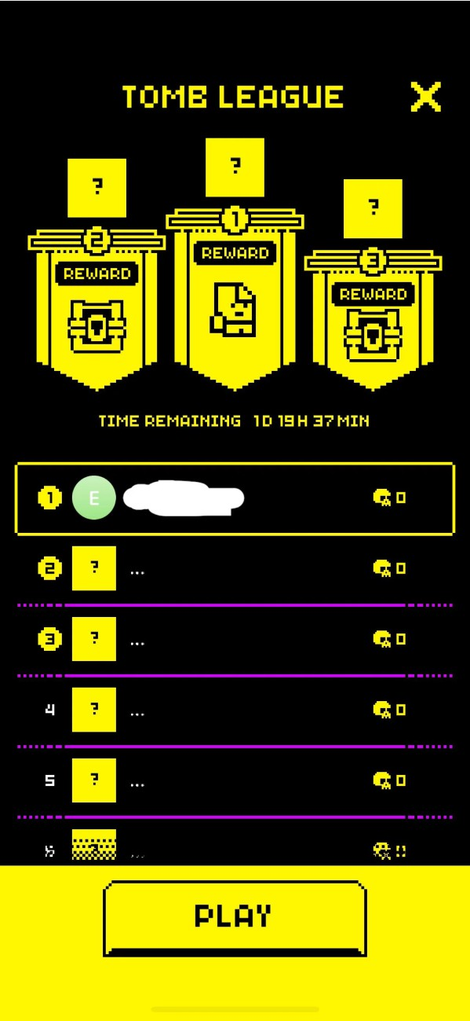

I can validate the importance of a leaderboard feature by asking a series of questions to my stakeholders. I will exabit the data from these questions in form of a bar chart and will analyse the data from both bar charts after they are both presented.
STAKEHOLDER ANALYSIS OF LEADERBOARD FEATURE
Question 1:
“Do you like games where your progress can be compared to other players?”

Chart 1.2
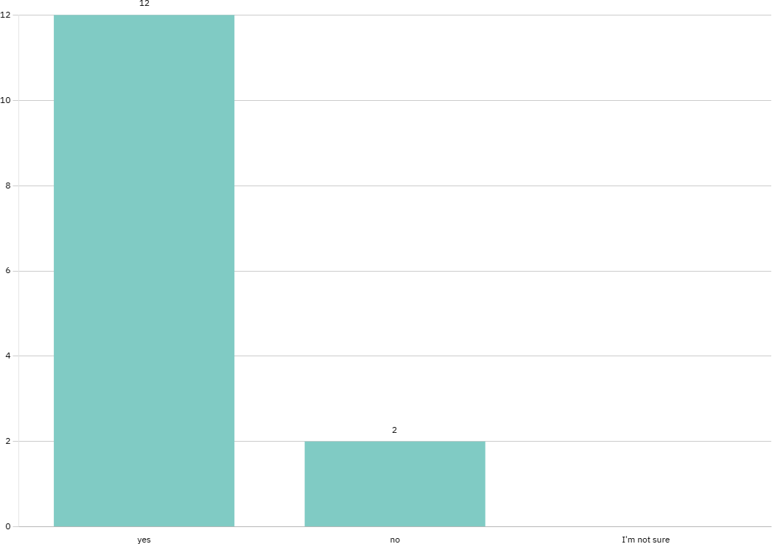

Chart 1.2 shows that:
- 12 people responded “yes”
- 2 people responded “no”
- 0 people responded “I’m not sure”
From this graph I can conclude that most of the players enjoy a completive game.
Question 2:
“Do you think a leaderboard is an effective way of creating competition in a game?”
Chart 1.3

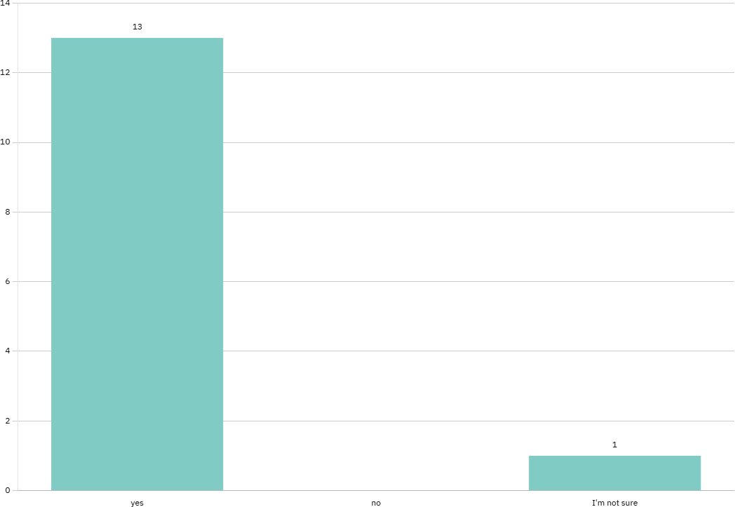
Chart 1.3 Shows that:
- 13 people responded “yes”
- 0 people responded “no”
- 1 person responded “I’m not sure”

Analysis of chat 1 and chart 2:
Both Question 1 and Question 2 aimed to gather a more in-depth idea of what the stakeholder expects from a competition in games. Question 1 confirmed that the users value a sense of competition in the game as they want to compare their progress to the progress of other players. This is, in essence, the core concept of game competition as it is player verses player. From here, I asked the stakeholders if they believe that a leaderboard is an effective way of creating this competition, to which their responses indicated the answer is an overwhelming yes. Despite the majority agreeing, there was one stakeholder who selected “I’m not sure”. Upon following up with this, I realised that the reason they selected this is because they mostly play simulation type game where competition is not a key aspect. This person also selected “No” for the first question. This indicated to me that while most people do indeed enjoy the aspect of competition in games, there are a few who do not. While this may present a problem in the

future, I believe that the majority outweighs the few in this circumstance. However, if the player does not wish to partake in the competition, he/she can always choose not to sign up and thus not be rated.
Overall based on the interview and data gathered by my stakeholders, I conclude that a leaderboard will be implemented into my game to create a sense of competition that the stakeholders desire. This will therefore become an essential feature of the game.
End analysis
To implement this, I will be implementing an SQL database. The database will store user information such as, Player Username, Player Password, Player High score and all-time high score. This information will then be displayed to the user in the main menu. He/she will have to login by creating a username and password upon first playing if he/she wishes to participate in the completive aspect of the game. More information about the development of this system will be presented in more depth in the design section of this document.

PREEXISTING VERSION OF TOMB OF THE MASK
I would be remiss if I did not mention the already wildly successfully game “Tomb of the Mask” which I am quite obviously creating a parody of. This is thus an existing solution that I am obligated to talk about.
The game that I am creating will follow Tomb of the Mask’s theme and overall gameplay style but is slightly different to the extent and score of the project as will be outlined is more detail in the limitation section of this document. For example, there are many different game modes available in the real version of Tomb of the mask that will not be implemented in my version due to various time restraints and complexity of their implementation. All the essential features outlined above are in fact essential features of the original game.

GAMES SIMILAR TO TOMB OF THE MASK

Tomb of the Mask is a unique game. It combines aspects of both a platformer and a dungeon crawler. I will now explain both an instance of both a platformer game and a dungeon crawler game explaining how they differ from tomb of the mask and how they are similar. In doing so, I hope to achieve a wider

view of all the different types of games on the market and get into the mindset of the developers of the original version of Tomb of the Mask to see what inspired them to make the game the way it is. This will then in turn inspire me to create the best implication possible of their game, satisfying my stakeholders.

DONKEY KONG
Donkey Kong is a classic platformer and was in fact the first platformer game ever made. In this game, the user tries to save a princess who was captured by a huge monkey – Donkey Kong. To do this, the user must travers through a planform to reach Donkey Kong while dodging the barrels he is throwing at you. Below is a screenshot taken from the original version of Donkey Kong.

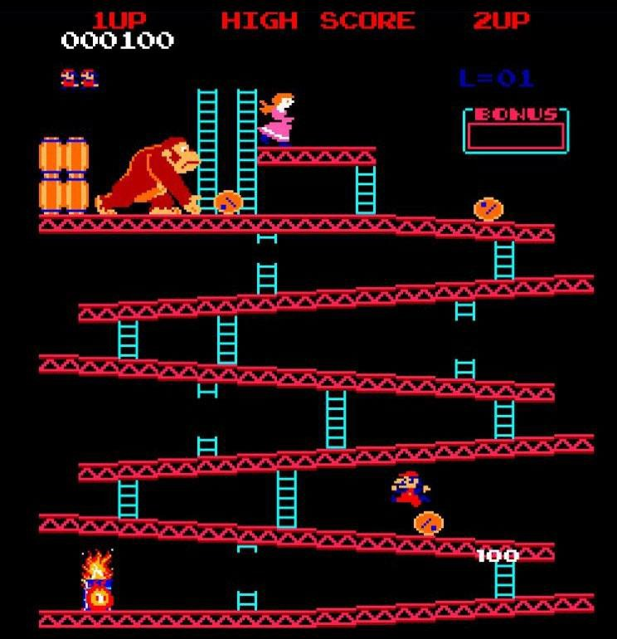

This game is similar to Tomb of the Mask in the aspect that it is a platformer. In TOTM, the player traverses vertically and horizontally through a maze, a platform, much like the player does in Donkey Kong. The player also has to doge barrels and obstacles in donkey Kong, like how they would doge spikes and bats in Tomb of the Mask. The intension to do this in both games is to gain a higher high score and beat other players. The simplicity and intrinsically completive nature of Donkey Kong have attributed to its success throughout its years along with the fact that it was the first game of its type. This can too be said about Tomb of the Mask as it has presented players with a unique opportunity to be competitive through its unique combination of mechanisms. Therefore, by analyzing the success of Donkey Kong, I

can see what I must include in my implementation to equally satisfy my stakeholders and make a successful game.
The key difference between the two games arises in the way the player traverses the platform. As in Donkey Kong, the player is free to move up, down, left and right at any given time. However, as we have discussed in depth previously, in Tomb of the mask the player cannot change the direction of travel until they collide with a wall, continuous directional movement until collision. This is in fact the key distinguisher between Tomb of the mask and every other platformer game in existence and is why I have chosen to create the game for this project. This unique mechanism has most certainly contributed to the profound success of Tomb of the mask as it presents players with a new and intriguing form of platformer that presents challenges and competition in ways unseen before by any other game.
It can therefore be said that the unique selling point of Tomb of the Mask is the combination of continuous directional movement until collision as it was the first game to combine these two aspects. It can therefore also be said that the unique selling point of Donkey Kong was the fact that it was a platformer game as it was the first ever game to do this. In this way, by analyzing Donkey Kong to find its unique selling point I have found Tomb of the Mask’s unique selling point and can therefore create a better and more successful implementation of it.

MINECRAFT DUNGEONS

Minecraft Dungeons, released in 2020, is a combination of the popular freestyle game Minecraft and a classic Dungeon crawler game. In this game, the user collects better gear and weapons to progress through harder dungeons fighting progressively harder monsters which drop better loot. It's essentially a cycle of getting better gear and then being able to progress further into the dungeon. This is not very simar to Tomb of the Mask when looking at the two games as a whole. However, the aspect that is, is the exploration of unseen and new dungeons that feel unique and often lead to the player becoming fully immersed in that world. In Tomb of the Mask, this is done through procedural generation as each time the player plays the game they can expect a completely new and unique feel which is exciting and intergang. By analyzing the way Minecraft Dungeons creates this feeling, I was able to deduce this and lead to the conclusion of the importance of this feature in my implementation of Tomb of the Mask. This

is because it will lead to a more immersive game and therefore higher player satisfaction. Below is a screenshot of an example of a dungeon in Minecraft Dungeons for reference.
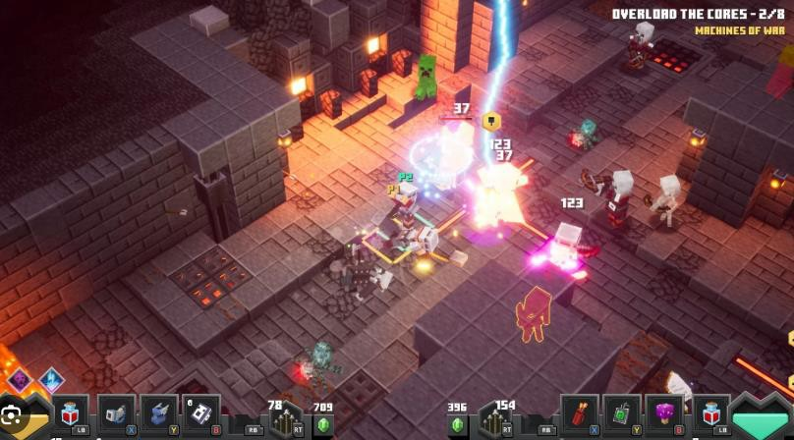
In this picture you can see the player fighting different monsters in a dungeon with the gear they collected seen in their hot bar.

LIMITATIONS
The main reason for the shortcomings of this implementation of Tomb of the Mask is either time constraints or cost. I will now walk you through each limitation and why I have chosen to rule them out of development.
ONLINE ACCESS
One main limitation is the fact that the game will not be available to play online and will only be available via download. This is because to put the game online there would have to be a server to host the game’s files and player databases which is costly and would require a significant amount of time to implement the front-end application. This would not only slow down the process of the game due to more lines of code needed to be executed and potential latency in communications between the front-end and back-end of the server, but would also delegate development time of core aspects of the game which may potentially lead to a worse and more buggy version of Tomb of the Mask being developed. Both will overall lead to a worse player experiment and thus lower player engagement as who likes playing a buggy and laggy game?

The trade-off and upside for this feature is that it would increase the number of players who have access to the game by decreasing the user hardware and software requirements. It does so by putting the computational strain on the server side rather than on the client side. Therefore, if the player has internet access, he/she can play the game. This increase in player volume, however, I believe is not worth the sacrifice in quality. I therefore believe that while not implementing this will lead to less players, the players that I will have will be more loyal and have a better experience.

UNIQUE LEVELS
As I have discussed before, I will not be creating unique levels for this game. The main reason for this is because it will take far too long to create enough levels for the game to feel complete. The time spent creating these levels will be essentially wasted and the opportunity cost is far too high, as this time can be better spent on developing more essential features. Therefore, as was previously outlined, I will instead be using precaudal generation to create a dynamic feeling game with no end. The main downside to this is that the game may feel unattended to and thus die out, as in the original version of Tomb of the Mask new levels are constantly released which increases player engagement. Therefore, players may feel like they are not valued.
KEYBOARD CONTROLS INSTEAD OF SWIPING
The original version of the game was created for IOS and Android while my implementation is created for Windows. This means that my game will not be able to be played on mobile devices where the preferred touchscreen interface is used. Instead, keyboard inputs will be the only way to control the agent. In the original game, the feature of continues directional movement until collision, which was discussed extensively above, was made unique due to the satisfying swiping action in which caused the player to move. However, as keyboard inputs will be used instead of touchscreen inputs, this swiping action will not be possible. This will potentially lead to the deflation of this key feature.
The reason why I have decided not to allow this game to be played on mobile, despite the obvious benefits, is because the implementation a mobile app is far more complex and time consuming than the implantation of a simple Windows desktop app. This would increase the scope of the project and again take time away from developing other key features such as procedural generation.
GRAPHICAL AND ART LIMITATSIONS
The original Tomb of the Mask featured high-quality visuals developed by a team of professional artists, including detailed animations, character skins, and stylised environments. In contrast, as a solo developer with a focus on computer science rather than digital art, I have chosen to adopt a minimalistic and functional art style. While I acknowledge that visuals play a significant role in user experience, creating detailed graphical assets would considerably increase the project's scope and divert valuable time from implementing core gameplay mechanics.

This approach is similar to many beta or early-access releases of successful games, where visual polish is secondary to developing and refining the main systems of the game.

HARDWARE AND SOFTWARE REQUIREMENTS
This section illustrates the minimum hardware and software requirements needed to run the game.
HARDWARE

Minimum Hardware  requirements | Reason | Justification
2 GB RAM  (preferably DDR2 or above) | Python 3.11, alongside Pygame, require at least 2 GBs of RAM to run the essential features of the game. This is because the game code must be loaded into RAM alongside essential features needed to run the OS. | If there is not enough space in the RAM to load the program, the game will not run. This is because, Python will have to load the full game code into the RAM from the storage.  Therefore, the system must have enough RAM to run both the OS and the game code. It should also be above DDR2 as to allow the data to be read/written, and thus  accessed, faster.
UNKNOWN AMOUT OF STORAGE. TO BE FILLED IN WHEN KNOWN | There must be enough room in the storage to hold the .exe file of the game. | If the file is stored on an SSD, then the computer will be able to access the file at a quicker rate than if it was stored on an HHD. This is because SSD’s typically have faster read/write speeds meaning the data can be copied to the RAM and CPU to be executed faster. This will allow for faster loading times and a smoother game play.

Intel i3/Ryzen 3  (2 core with minimum 2.0 GHz clock speed) | To run python scripts there must be enough computational power to execute the code. | Having two cores instead of one allows for Parrell processing which increases the Proformance of the CPU by allowing multitasking to take place. This alongside more cycles of the Fetch decode cycle being carried out per second is essential as it will allow the game to run at a constant 60 frames per second. This is vital to provide a smooth gameplay  experience for the player.
Standard Keyboard | The player must be able to input W, A, S and D to control the argent’s movement. | The user’s keyboard must include the W A S and D keys. Other language keyboards will work if the computer recognises that the inputted keys, independent of the language on  them, are identic to that of the English counterpart.
Standard USB or wireless Mouse | The player must be able to navigate through the main menu. | For the game to start the button “Start”/ “play” must be pressed in the main menu. Moreover, many features of the GUI will be  inaccessible without a mouse.
Internet connection  (Vital for leaderboard information/competitive play game will run without) | The player’s computer must be able to connect internet to access the database. | The database hosts player information and their position on the leaderboard. This database will be stored on a server online and if the player does not have an internet connection, they will not be able to access it. The game will still run if the player does not have an internet connection, but they will not be able to see their position on the leaderboard or login.
Moniter display  Refresh rate of <=60hz with Vsync enabled, formatting of at least 800x600 pixels (recommended) | The game must be displayed/outputted correctly so that the user can use the output to justify an input. | The game is formatted at 800x600 pixels. The players display should therefore be at least 800x600 pixels so that the game will fit on the monitor display without having to be shrunk which would decrease  the experience.

The game should be run with Vsync enabled (if allowed by the GPU and monitor) as to match the frame rate of the game. This will make the game feel smoother and this increase player experience. The refresh rate of the monitor should not be lower than 60Hz as the
minimum frame rate will be 60 fps.
A GPU of minimum power equivalent to that of a NVIDIA GT 710 or AMD  Radeon R | The graphical calculations to render an output on the monitor must be completed successfully. | The game is not graphically demanding as it is only in 800x600 resolution and only in two dimensions. However, there are still calculations that must be done to render the objects onto the screen, therefore, a GPU is needed. The more powerful the GPU the higher frame rate the player will  experience.
HD audio speakers (recommended) | To display the audio outputs of the game. | To heighten user experience,  the game’s sound effects should be auditable. However, the game will run without a  speaker.

SOFTWARE

Required software | Justification
Windows 7 or later (64-bit) operating system | The .exe file is compiled for Windows systems. Windows 7 and later support the necessary system libraries and APIs for modern Python and Pygame applications. 64-bit is recommended for  better memory management and compatibility
DirectX 9 or later | Required by Windows to handle graphics and audio operations.

Microsoft Visual C++ 2015-2022 Redistributable | Some dependencies used during .exe compilation (via pyinstaller) may require these redistributes to be present.

SUCCESS CRITERIA

In this section, I will be outlining the criteria that I must meet to quantifiably validate that my project has been successful upon completion. I will also justify each criteria stating why each one is important to the overall experience. This will be used as a reference throughout the project to keep me on track and define a clear scope for the project.

- User experience:
  - Main Menu:
    - Ease of navigation:
The Menu should be easily navigated so that player retention is high and so that the player does not get confused. This is because the player must be able to find each aspect of the game. For example, they must be able to locate the start button and Leaderboard. This can be quantified by completing a survey with my stakeholders where they will rate how easy it is to navigate the main menu on a scale of 1-10, where 1 would represent a menu that is hard to navigate and 10 a menu that is easy to navigate.

The menu must be responsive:
The menu must respond in under 150ms, as otherwise the game will feel slow and unresponsive. This will lead to low player retention and decrease the playability of the game. To test this, time the time for the buttons to respond using the internal pygame clock and break points.

The menu must be functional:
Each button and feature that is in the main menu must do what is advertised. For example, the start button must start the game, and the leaderboard function must display a leaderboard. This must be the case otherwise the game will not be functional or complete, and the player will become frustrated. This can be tested by issuing a stakeholder survey in which they rate the functionality of each button on a scale of 1-10, where 1 is bad and 10 is good.

1.1.3 Visual feedback when navigating the menu:

The player’s cursor must be viable when navigating through the menu so that he/she can see where they are pointing. Moreover, if the player is hovering over a button, it must give feedback to the player that it is being hovered over by slightly changing color. This will make the game feel more polished and increase the user experience. This can be tested by another survey given to the stakeholders who have used the menu to determine (on a scale of 1-10) the effectiveness of the button hover color and the ability to track the cursor.

The game opens with a splash screen:
While the game is loading, instead of there being a dark/black screen, there will be a splash screen with the Tomb of the Mask logo. This will make the game feel more complete and more polished and overall lead to better player experience. This can be tested by a yea/no stakeholder survey where the stakeholder identifies if a splash screen is present when they load the game or not. This will tell me if the splash screen consistently loads every time for every player.

The player should be able to change game settings in a dedicated settings page:
    - Audio:
The player should be able to adjust the loudness of sound effects through a sliding volume adjuster whose functionality and usability will be quantified through a survey with stakeholders who will rate the feature from 1-10. A high quality and functional sound scaler will make the game feel more complete and allow the user to control how loud they want the game.

Difficulty scaler:
The player should be able to change the difficulty of the procedurally generated maze on a scale of 1-5 where 1 is easy and 5 is hardest. This will allow for the game to be appealing to the stakeholder who wants to play an easier game while also allowing the more completive players to play a harder game. Overall, increasing the playability of the game and broadening the demographic. This feature should be easy to use and functional. Both of which will also be justified by a survey given to stakeholders from 1-10 where they can rate their general experience with the feature where 1 is a bad experience and 10 is a good experience.

Sound effects:
    - Representative of game mechanics:

The sound effects must “match” what is happening in the game. This means that, for example, the sound that plays when the player collects a coin should thematically make sense. This can be quantified by a yes or no survey given to stakeholders where they identify if they sounds match or not. This will be done for every sound effect in the game. This is important so that the game flows and feels professional. This is also important as it will infuriate the player if a mechanic appear to have no effect or the wrong effect.

Sound must play with low latency:
There must be a latency less than 100ms before the sound effect plays. This will make the game feel more dynamic and increase user experience and can be tested using the internal pygame clock and breakpoints.

Sound must be high quality:
The sound effects must have no static and be in HD so that the player will feel more emersed in the game when the sound is of a higher quality and it will thus improve the user experience. This can be tested through a stakeholder survey from 1-10 where they rate the overall quality of the sound effects. However, this may be subjective and relative to the speakers the player has.

Aesthetic and Theme Consistency
    - Consistent Visual Style:
Fonts, button shapes, and colours should match the theme of the game (e.g., retro arcade). This will be quantified by giving a survey to stakeholder where they will rate the overall aesthetic of the game on a scale of 1-10. This must be done as if the buttons or sprites feel out of place it can disorientate the user and lead to them having a worse expiring. Therefore, to heighten the user experience, there should be a consistent fell.

1.6.2 Animated Transitions:
Smooth fade-ins/outs when switching menu screens to make it feel more dynamic and professional. This will again lead to a more engaging and immersive feel for the game and increase the user's experience and can be quantified through a stakeholder survey from 1-10 where they rate the overall quality of the animations/transitions.

- Player Movement:
  - Continues directional movement until collision:
    - Must Be predictable and reliable:

The player must be able to predict how the agent will move when a direction is pressed. In this game, once a movement key (W, A, S, or D) is pressed, the player should move continuously in that direction until they collide with a wall or obstacle. This is essential to ensure that the player understands how to control the character and can play the
game strategically. This behaviour must be consistent. For example, pressing ‘W’ should always move the agent upward until collision, no variation should occur between plays. This will ensue that the player has the easiest and most enjoyable time playing the game, as in the end it is meant to be a relaxing endeavour for the player and not stressful. This will be tested through trial runs with stakeholders, where they will rate movement consistency on a scale from 1 to 10, with 10 representing fully reliable and expected behaviour.

Movement must be response:

The agent must start moving within 100ms of a key being pressed. A high input delay would make the controls feel sluggish and unresponsive, leading to player frustration and negatively impacting gameplay.
This is particularly important for a fast-paced arcade-style game like this one, where reaction time and quick controls are vital. This can be tested using the internal pygame clock and breakpoints.

Movement must be restricted to cardinal directions:

To make the game fair and maintain its retro aesthetic, the player should only be able to move up, down, left, or right where no diagonal movement should be possible. This simplifies control and keeps the game mechanic like the original Tomb of the Mask. This will be verified by testing whether diagonal input (pressing two keys at once) results in no unexpected behaviour where stakeholders rate their overall experience with this on a scale of 1-10. Stakeholders will also confirm via a questionnaire if they ever observed unintended movement.

- Core gameplay mechanics:

  - Coin collection:

    - Coins must be collectable when touched by the player:

When the player moves into the same position as a coin, it must be removed from the game space and added to the player’s score. This mechanic should work every single time a coin is touched. This creates a reliable feedback loop that rewards player progression and contributes to the overall purpose of the game; gaining a high score. This will be tested by placing coins in specific areas and confirming through gameplay

that they are consistently collected upon contact. Stakeholders will also give feedback on whether coin collection feels accurate and consistent in forms of a year or no answer. This must be predictable as mentioned before as it will lead to a worse game play experience.

score must increase when coins are collected:

Each coin collected must add to the player’s score in real time. This should be displayed clearly during gameplay, so the player can track their progress and therefore lead to higher player engagement. This will be verified through direct testing and stakeholder feedback on whether the score updates as expected.

score must be saved to leaderboard (if internet connection is present):

If the player is logged in and connected to the internet, their final score at the end of the game should be uploaded to the leaderboard database. This will be tested by ending a game with a connected account and checking that the score appears on the leaderboard page. This is important as it will heighten the competition aspect of the game, as if their high score is not updated, there will be no sense of getting a high score and thus no reason to compete in the first place. This will be failing on the entire competition feature of the game and would decrease stakeholder and player satisfaction in the product.

Procedural generation:

    - Maze generated Must be completable:

For the game to be completable and playable, the maze generation algorithm must follow strict logic that ensures each maze contains at least one valid path from the
player’s starting position to the exit. This involves placing walls, paths, and hazards in such a way that there is always a clear solution, regardless of the difficulty level selected. If this requirement is not met, mazes could become unsolvable, leading to extreme player frustration, broken gameplay loops, and reduced engagement.
Therefore, the procedural generation algorithm must always prioritise level integrity and solvability. This will be tested through repeated gameplay sessions and debugging overlays that visualise the maze’s solution path. In addition, feedback from beta testers and stakeholders will be gathered to confirm that the mazes feel fair and always completable.

Maze must reflect selected difficulty:

The procedural generation system must adapt based on the difficulty level chosen by the player where Easy = 1, Hard = 5. Higher difficulty levels should result in longer mazes, more frequent obstacles, tighter spaces, and more enemy spawns, while still ensuring fairness and balance. This allows players of all skill levels to enjoy the game and provides a challenge for those who want it. This will be tested by generating mazes across all five difficulty levels and comparing the number of branching paths, hazard density, and maze complexity. Stakeholders will also be surveyed to rate how appropriate and balanced each difficulty level feels.

Coins and hazards must be placed logically and fairly:

Coins should be placed along valid paths in a way that encourages exploration without feeling impossible or unfair. Hazards, such as traps or moving enemies, must also be placed in a way that adds challenge without making completion impossible. Placement should feel intentional and designed, even though it is procedurally generated. This will be tested through multiple tests runs with varying difficulty settings. Stakeholders will be asked whether coin placement and hazard frequency felt random, unfair, or enjoyable. This is important as it will ensure that the player can acquire a fair number of coins and that the game is playable in this aspect. As if there is an unattainable coin the game will feel “broken.”

Collision detection:

Accurate collision detection must be implemented to ensure that the player cannot move through walls. This is a core mechanic that defines the limits of the maze and creates the need for strategy. This will be tested by attempting to move into every wall in a test level. If the player never passes through, the mechanic is working as intended.

- Database functionality:

  - Player Data Management:

    - Store essential player data securely:

The database must store key pieces of player data, such as usernames, high scores, and unique user IDs. This data will be used to track progress, enable competitive features like leaderboards, and personalise the user experience. It is important that the data is stored in a secure and structured, normalised format. This ensures the data can be accessed, read, and written to efficiently and without corruption. This is important because it means that the user can trust the game, and me, with their data and to comply with the data protection act of 1998, which I am legally required to comply to.

This will be tested by registering multiple users, saving their scores, and confirming that the correct data is retrieved every time the leaderboard is loaded, or the player returns.

Leaderboard Integration:

The leaderboard must dynamically update to reflect the highest scores of all players. This data must be fetched from the database and displayed in the correct order (descending) to ensure fair competition. The scores must be updated in real-time or after a match has ended. A leaderboard that does not refresh or display scores correctly will reduce the competitive appeal of the game and could frustrate users. This will be tested by submitting test scores from different users and checking that they appear correctly in the leaderboard immediately after submission.

Data Validation and Integrity:

Any player input that is sent to the database (e.g., usernames or score values) must be validated to prevent bugs or malicious data entry (e.g., SQL injection or invalid characters). For example, the system should limit usernames to a maximum length and disallow special characters that could break the database structure. This will be tested by entering various forms of valid and invalid data and confirming that only appropriate inputs are accepted and stored.

Section B. Design

INTRODUCTION AND OVERVIEW
In this section, I will illustrate the plan for the development of this game. I will use this section to cover data structures, GUI features, and tests for determined solutions. Throughout this, I will be closely working with my stakeholders to gather a deeper understanding of how they want the game to develop.

I am using an agile development approach for the development of this section meaning that the final solution will be created over many iterations, each improving on the next with input from stakeholders. I am using this because it will allow me to obtain a creation that is closely linked to the stakeholders' needs and requirements, thus yielding a more desirable solution for them. It is also the most time conservative method in this use case, as the user’s requirements will inevitably change and, in this mythology, changes are embraced, and the solution is adapted to accommodate them. Whereas other mythologies, such as waterfall mythology, will require a full change of the analysis sections and design section, which will be very time consuming.
This means that the design of the solution outlined in this section will be subject to change and is thus a template that I will follow in the iterative development sections. Changes to this design will be made apparent in the iterative development sections of this document.

PROBLEM DECOMPOSITION
As I have mentioned in the analysis section of this document, the decomposition of the problem is vital for the success of its development; it will allow me to break the problem down into smaller, more meaningful, sections that will make the problem more tangible and completable which will allow me to tackle them more effectively and hopefully lead to a better solution being developed. Below is a hagiarchy diagram illustrating how I have broken down the large problem into four smaller sub-problems.

Figure 2.1

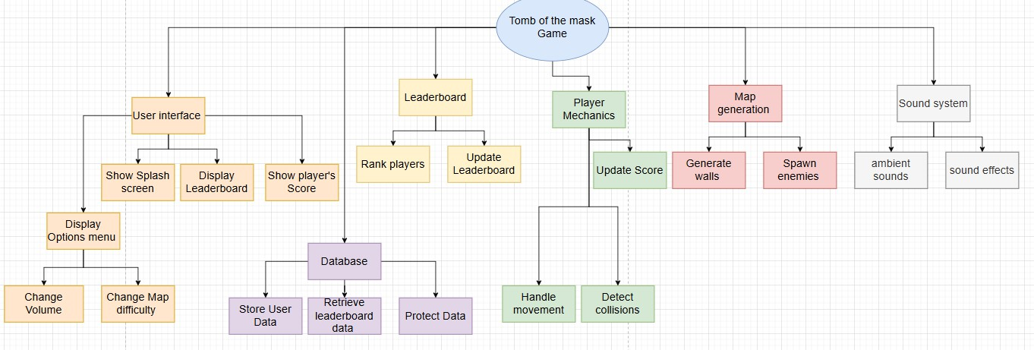
Figure 2.1 shows the decomposition of my game into its core functional components: User Interface, Leaderboard, Database, Player Mechanics, Map Generation, and Sound System. These six elements represent the primary features required for the successful implementation of the game. Breaking down the problem in this way enables modular development and clearer project planning, as each component can be designed, tested, and refined independently while still contributing to the overall system.
This structured approach is crucial for managing complexity, reducing development time, and improving debugging and maintenance. By separating the system into discrete modules, changes or improvements can be made to one part of the game without affecting others, promoting scalability and flexibility in development. For example, if the Map Generation algorithm needs adjustment to improve gameplay variety, it can be modified independently without requiring changes to the User Interface or Database components.
Furthermore, this decomposition aligns with software engineering best practices, such as the principles of abstraction and encapsulation. Each module can be defined by its inputs, processes, and outputs, which enhances clarity and supports better code reusability. For instance, the Leaderboard can be reused across different games or versions by maintaining a consistent interface with the Database and UI layers.
Moreover, this decomposition ensures that the game meets its functional and usability requirements as outlined in the success criteria, such as responsiveness, accuracy of scoring, player engagement, and ease of navigation. In the following sections, I will explore each aspect of these core components in greater depth, breaking them down further and providing supporting flowcharts and pseudocode to illustrate the internal logic and data flow within each module.

STRUCTURE OF THE SOLUTION & BREAKDOWN OF INDUVIAL SECTIONS
I will now illustrate the structure of each core section of the game. I am splitting it up into smaller sections rather than one large diagram as it would not fit on the page otherwise. I will then go through the design of each section involving stakeholder input.
USER INTERFACE

Figure 2.2
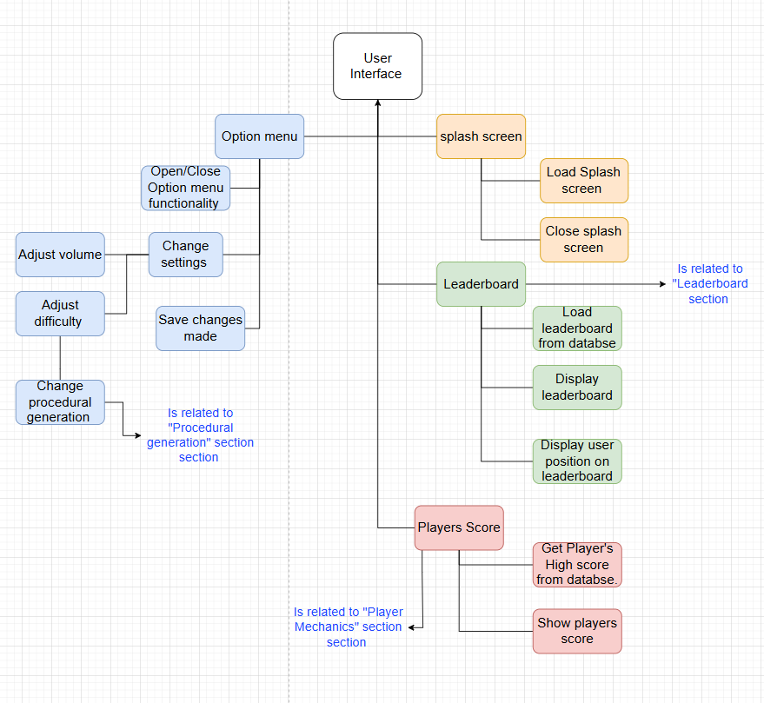

In this section, I have broken down the User Interface into four main sub-sections each of which will become their own function or sub-program in the main program.

Splash screen

The splash screen will load upon the game opening and must only be present and loaded for an unknown amount of time until the rest of the program has loaded from memory. This will give the player a smooth game playing experience. This means that there will have to be a subprogram that reports on the progress of the loading of the main program so that when the program is fully loaded it reports back to the splash screen program telling it to unload itself. This flowchart shows an outline of how this mechanism works. The flowchart shows that the program will start with the splash screen loaded, as this program will be the first one to run in the main program and thus no previous checks are needed. This means that regardless of if the program is loaded or not, the splash screen will load in the beginning.

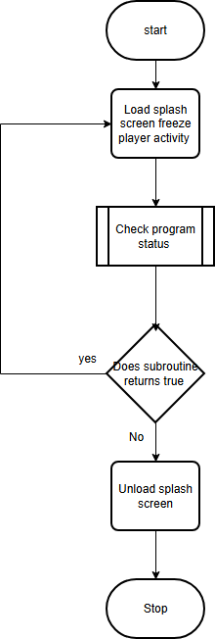
The subroutine “check program status” will do just that: it will return either true or false. None if the program is not currently loaded and True if it is currently loaded. If None, the program will continue to load the splash screen. Otherwise, the splash screen will be unloaded. This leads to a potential issue of the splash screen not being loaded at all or potentially being loaded for a short time that will not be comprehendible for the user, especially if the user has a powerful computer as, the program will load nearly instantaneously. Therefore, to ensure that the
splash screen is loaded for enough time, there will be a set “add 3 seconds” to the check program subtribe until it can return False.

The Design of the “check program” function is rather simple. It will merely consist of a few lines of code that oversee loading the core aspects of the game, i.e.: sound files, sprite animations and background
images, with a simple “Return True” statement at the end. Meaning that it will only return once all the aspects are loaded from memory. Here is a simple Pseudocode snippet of how this will work, demonstrating what is said above.

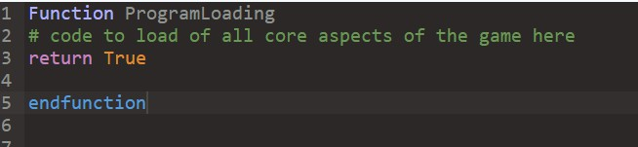
LEADERBOARD GUI DESIGN
The displaying of the leaderboard mechanism portrayed in this section is not to be confused with the functionality of the leaderboard and database that is outlined in the section below. This section implies that the loading and processing of the leaderboard has already been done in a separate sub-process from the database and is fully concerned with the displaying of said data in a sub-menu that the player must be able to access. The figure below outlines a prototype of how the leaderboard will look.
As is apparent, I have chosen a yellow on black color scheme the match the original version of the game. The figure shows how the top 3 players with the highest score will be placed in descending order in a Pedi stool manor displacing their name and respective score below. This is to be front and center to highlight the significance of their achievement. Below them are the next top nine best players with their respective high scores depicted to the left of their name. The user's score is then depicted below them along with where they rank in terms of other players on the leaderboard. This is depicted with an “XXXX” in the figure as this number will change depending on the player's high score. Moreover, if they are present in the top nine players, in accordance with success criteria 4.2, There name must be highlighted there.
Below the leaderboard is a “Back to main menu button.” This will do just that, redirect the user to the main menu and collapse/unload the leaderboard page. Below figure 2.3 I will illustrate a flowchart for this mechanism.
Figure 2.3


LEADERBOARD
TOP PLAYER SCORES OF THE GAME


#1 

PLAYER NAME HERE

Top score
#2 #3
PLAYER NAME HERE PLAYER NAME HERE

Top score Top score
#4 | INSERT NAME HERE | 3988
#5 | INSERT NAME HERE | 3843
#6 | INSERT NAME HERE | 3754
#7 | INSERT NAME HERE | 3666
#8 | INSERT NAME HERE | 3455
#9 | INSERT NAME HERE | 3333

#XXX COWN PLAYERS HIGH SCORE HERE=:> xxxx

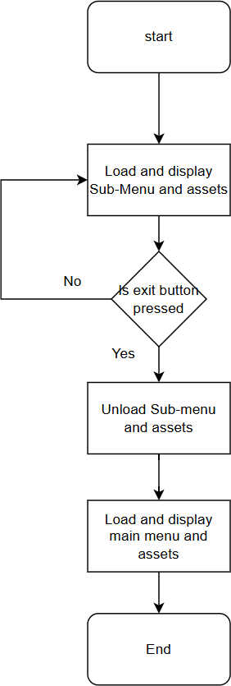

than 150ms.
This simple flowchart shows how all “Back to main menu” Buttons will work, not just the one depicted in Figure 3 above. It starts by assuming that the button to load the sub-menu is already pressed, as it will begin by loading the sub-menu. The logic behind the command to start this process will be illustrated in flowcharts in a feature section of this document. Next, the program enters a while loop assessing whether the exit button has been pressed or not. This will run continuously as the program is running. This may not seem to be the best approach as it takes up processing power, however, the amount of power that it takes in minuscule as inbuilt functions in pygame allow it to be very efficient. An alternat approach could only check the status of the button every few seconds but the flaw on this pretty obvious; what if the user presses the button and the program is not checking the status? This will result in the button seeming not to work and a worse player experience.

Once the program detects that the exit button has been pressed, it will unload the sub-menu, in this case the leaderboard menu, and all its assets. These assets could include any text or buttons that have been loaded onto the screen. Next, it will load back to the main menu. For this to be more efficient, it might be beneficial to never unload the main menu and merely blitz the new menu on top of the main menu and disable the old menus functionality to not consume too much processing power in the process.
This will lead to less strain on the CPU when having to load the menu from scratch when the button is pressed. This can also hopefully lead to less strain on the CPU if the player “spams” the buttons as this could potentially lead to a crash. Thus, reducing the responsiveness of the GUI which relates to success criteria 1.1.2 stating the buttons should respond in less

PLAYER SCORE

This component of the main menu is straight forward. It consists of a piece of text on the player’s screen, most likely above the “Play again” button, that states two bits of information: Players high score and Players most recent score. It will load the Player’s High score from a database and store it as a variable and then load it onto the screen. The Players' most recent score will be stored as an integer variable as well. It will update when the player dies. The explanation of how this works will be explained in more detail in the player mechanics section of this document.
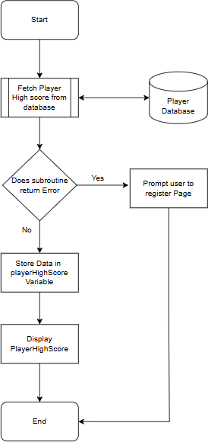
This Flow chart shows the process of loading the numerical value for the player’s High Score from a database called: Player Database. There is a
subroutine which will perform a Binary search on the dataset, searching for the player’s name and returning an integer value for their respective high score - this subroutine will be explained in much more depth in the database design section of this document. If the player's name, however, is not in the database of registered users, the subroutine will return an error as there will be no matches to the item. In this case, the user will be prompted to a register page where they can enter their usernames and passwords.

Once the player’s high Score is obtained from the database, it will be stored as a variable. This will take the form of assigning a variable to the function call itself. Once this is done, the value will be blitzed onto the screen.

OPTIONS/SETTINGS MENU DESIGN.
In this menu, the user must be able to change: the ambient music volume, sound effect volume, and the difficulty
of the procedural generation in a sub-menu dedicated to changing essential settings of the game. This sub-menu, like all other sub-menus previously mentioned, must feel responsive to the users (defined as a response time less than 150ms), and any changes made to the settings must affect game play in a meaningful way representative of how the user changed said setting. For example, if a player were to change the volume by a, say, 20% increase, the user would expect the sound to become exactly 20%

louder, not to become 20% quitter or suddenly become max volume. Or, if the player increases the difficulty to notch 2 out of 5 from notch 1, they will not expect a massive increase in diffluent, merely a small yet noticeable increase. This arbitrary unit “notch” must scale linearly and feel smooth. The same can be said for the audio volume.
To achieve this for the volume side of things, all sound effects will be managed by the inbuild pygame function Mixer, in particular the .set_volume(volume) function. This works by defining a variable per sound effect (such as pop) and then doing pop.set_volume(volume). However, as there will be many sound variables due to there being many sounds effects in the game and to ensure that all sounds are changed at the same time, I would manually have to type out the line for each specific variable. This is not only time-consuming but also wildly inefficient.
To resolve this, a global volume variable will be defined. Rather than treating each sound as a standalone variable, sounds will be structured as objects within a class that includes a volume attribute. This attribute will reference the global volume variable directly. As a result, when the global volume is adjusted, all sound objects will update accordingly in real time. This ensures that the changes made by the user will be meaningful and representative. A more detailed explanation of this system, including the class structure and implementation, will be provided in the "Volume and Sound System" sub-section of the design documentation.
The ambient sound adjusting on the other hand is far easier to implement as there will only be one variable to change the volume to. This is because at any time there will only be one soundtrack playing. Therefore, I can just do .set_volume(volume) without running into any redundancies.
Another key aspect of this sub-menu is visual feedback to the player. This is important because it gives the player a sense of scale and reference when changing settings. This is especially important for changing the volume because sound (in decibels, Db) is measured on a logarithmic scale, meaning 55 Db is twice as loud as 54 Db. This can be hard for users to comprehend and to avoid confusion it is offer reduced to a liner axis in games. This will be handled by pygame. Therefore, this means that I will depict a liner scale for volume. It is also important to note that it must be done as a percentage as the function
.set_volume(volume) takes the volume parameter as a percentage of the original volume's max amplitude. In other words, 100% is the initial volume of the sound effects.
There are many ways in which games do this, whilst all following the same generic theme, they differ in the design implementation. The most popular is a volume adjustor with a sliding control system, where the user slides a bar between 2 fixed points corresponding to 0% and 100%. The distance the sliding bar is from the first bar corresponding to 0% indicates the percentage of loudness the volume will be at. A ruff depiction of this is shown below.

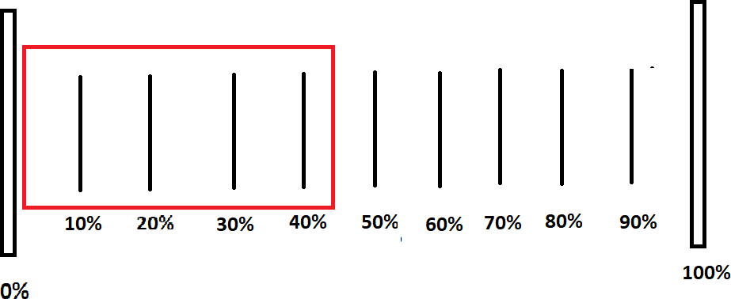

In this depiction, the 2 larger fixed bars at either end represent the maximum and minimum values that volume can be: 0% and 100% respectively, thus making all percentages in-between this range valid. The red rectangle shown is an attempt to show the percentage a user has sent the volume to be. In this case, 44%. It will be molded into a sprite. The bottom part consists of the smaller lines, and the larger lines will also be molded as their own separate sprite. It can be imagined that the user can “grab” the end of the red rectangle with their mouse and pull/push it closer to either extremity to a new percentage that will represent the volume. The distance that the end of the red rectangle is from 0% corresponds to the percentage volume. To do this, there will be a constant defined named pixels_From_Extremities. It will, as the name suggests, hold the value of the distance between the two fixed bars. It is a constant because this distance is invariant and the user cannot move it. Next, there will be a variable defined named pixles_moved. It will hold the value of the distance between the end of the red rectangle and the starting point (0%). Now to calculate the percentage, simply do (pixles_moved / pixels_From_Extremities) x 100. The result of this calculation will be stored in the global Variable volume defined earlier. I will now illustrate this in pseudocode.
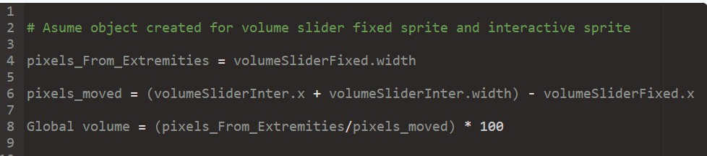
To understand this code, you first must understand that there will be an overarching sprites class which different sprites can be constructed from (this is explained in more depth in other parts of this document.) In this case, two objects are being used: volumeSliderInter and volumeSliderFixed.
VolumeSliderInter is the object being used to represent the red rectangle sprite depicted in the figure above and volumeSliderFixed is the object that represents the bottom, invaritent slider sprite. Each

object has an attitude width which defines the width of the sprite. A value will be assigned to each sprite for this attribute in the constructor.
In line 4, the variable pixels_From_Extremities is set to the width of the object and so it defines the distance between the 0% marker and the 100% marker.
Line 6 is slightly more complicated. It calls on the position of the bottom corner of the sprite (volumeSliderInter.x) and adds it to the width of the sprite. This is done to get the value for the x position of the front of the sprite, which is then subtracted from the x position of the back of the invariant sprite, therefore leveling the value for the width of the invariant sprite. This can be explained easier with help of the diagram shown below:
Line 8 demonstrates the logic explained above where to determine the percentage of the bar shown we need to divide the total width of the invariant object by the amount the other has moved, and then of course multiply it by 100 to make it a percentage.

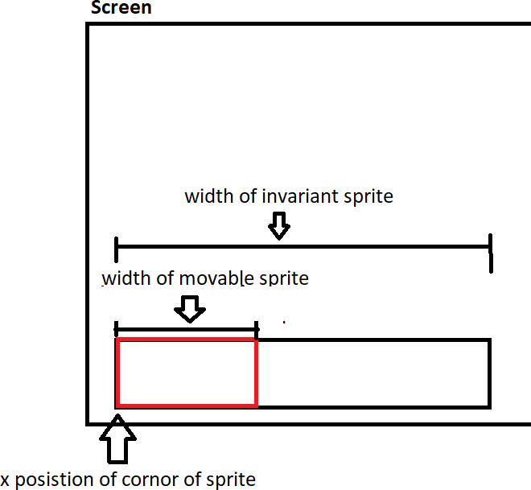

The “pull/push” mechanism for the volume adjuster is depicted in the flow chart below.

This flowchart consists of two while loops, each serving a distinct purpose. Separating the logic behind detecting whether the user is touching the sprite versus clicking the sprite ensures a smoother and more

intuitive interaction.
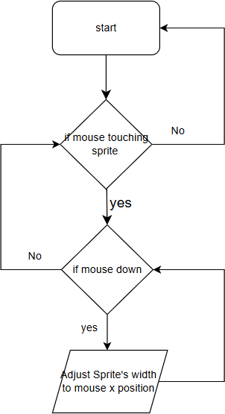
The key idea is
to allow users to adjust the volume even after moving their cursor off the sprite, provided they haven’t released their mouse. This prevents a “touchy” volume control experience, which could otherwise violate ease-of-use success criteria. By structuring the logic this way, the user must first hover over the sprite before clicking on it to interact.

Since the algorithm continuously runs while the sub-menu is loaded, it remains active as long as the interaction is needed. However, it’s
important to ensure resource efficiency to prevent excessive computational load.

The next part of the settings menu is the ability for the user to adjust the difficulty of the procedural generation. This will be done utilizing the preexisting button class by defining clickable sprites that, if clicked, will change how the map is created. The logic for the algorithm to do this will be
highlighted in the procedural part of this demotion. For now, here is an example of how the user interface will look.


Each of these buttons will be able to be clicked, and, according to success criteria 1.1.3, each button must also be completely functional and logical, meaning it will affect map generation in a meaningful way.
The colors of the different buttons are important as well. This is because each color has a representation and thus, they match/correspond to their respective difficulty due to connotations created from them. This is noticed if I were to violate the rule and use green for the hard button instead of red. This would clearly look wrong and confuse the user as they would expect it to be red. This will lead to a worse user experience and make the game feel unprofessional; therefore, strict color formats must be adhered to.

OVERALL BUTTON CLASS AND FUNCTIONALITY
The UML diagram below is designed to demonstrate clear object-oriented principles and to ensure my program is modular, reusable, and easy to maintain. At the top of the hierarchy, there is a base class called UIElement, which holds the attributes used by all user interface components, such as position and size, along with the draw() and update() methods. This prevents duplication and allows subclasses to inherit and extend shared behaviors. From this superclass there are the Label and Button subclasses who inherit from it. The Label class is responsible only for displaying text and therefore contains attributes such as text, fontSize, and colour. The Button class, on the other hand, is interactive, so I included attributes such as isHovered and isClicked, alongside methods like onClick() and isMouseOver(). This clear separation of responsibilities ensures that each class has a single, well-defined purpose. It will also mean that I can create as many labels and buttons as desired for the different menus through only a simple constructor.

From here, a Menu class is created which holds a list of Buttons and Labels that are present in one specific instance of a menu. This is a composition relationship, as a menu is made up of buttons and labels, and methods such as addButton, removeLabel, and clearAll allow these elements to be dynamically managed. This makes the menu system flexible enough to be reused for different parts of the program, such as the main menu, settings menu, and options menu. Encapsulation is also used by making attributes private to ensure that other classes interact with UI components only through their defined methods, preventing unintended side effects. Finally, the design makes use of polymorphism through the draw() method, which is overridden in each subclass so that the correct drawing logic is applied depending on whether the object is a button or a label.

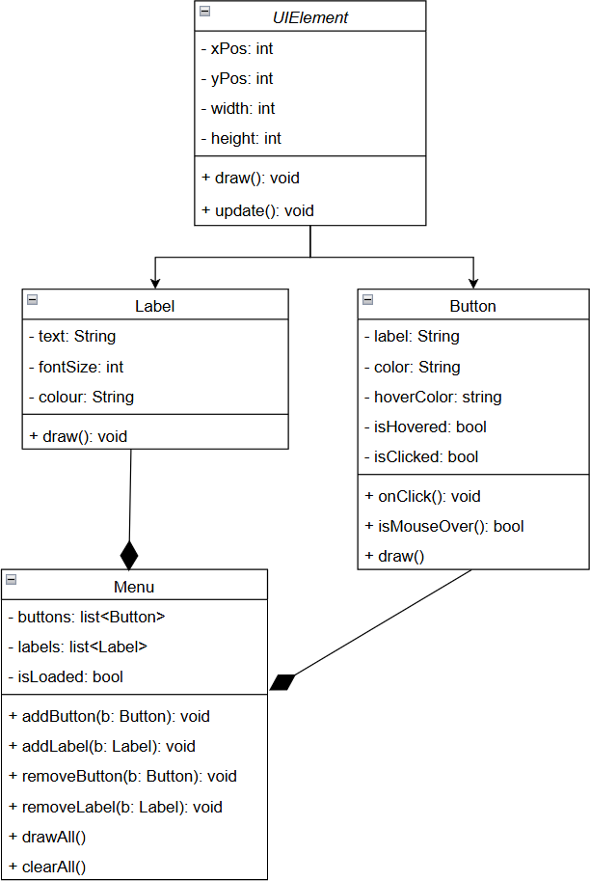

Explanation of methods:
When playing the game, there will be many different menus that can be loaded. For example, the main menu and the leaderboard menu. These, as depicted above, are treated as separate objects which

house a list of individual UI objects that are loaded onto the screen all at once. This is done in this way so that I would not have to manually go through each button and/or label to unload each one by one during changing menus. Instead, I can use compartmentalization and unload a whole menu at once. This then presents the challenge of knowing whether a menu or specific UI element is loaded or not and when it is to be loaded. To solution to this is straight forward and merely involves intruding a single boolean variable “isLoaded” which can be flipped True is the element is meant to be loaded and False if not. This will be an essential attribute for each menu which will be passed to each element in the menu list to load them concurrently.

Button explanation
The Button hovering and clicking meninism is even more intuitive than that aforementioned method where the name of the identifier (isHovered) practically explains the whole code behind it. Put simply, during the game loop the button will check if the players' mouse is within the rect of the button. If it is then it will update itself – by calling upon the update method – to change its color. When the program flags that the button is being hovered, it will permit it to process the command (onclick function) if the player clicks their mouse. Doing it this way ensures that the correct button is pressed when the player clicks. It also makes sure that if the player clicks off the button, nothing happens. The reason each condition can't be processed together is because it would not allow for the hovering color mechanism to work as it would only allow the object to change color if it were being hovered AND it was being clicked which defeats the point. Therefore, they must be separated. Below is a simple flow chart explaining this.

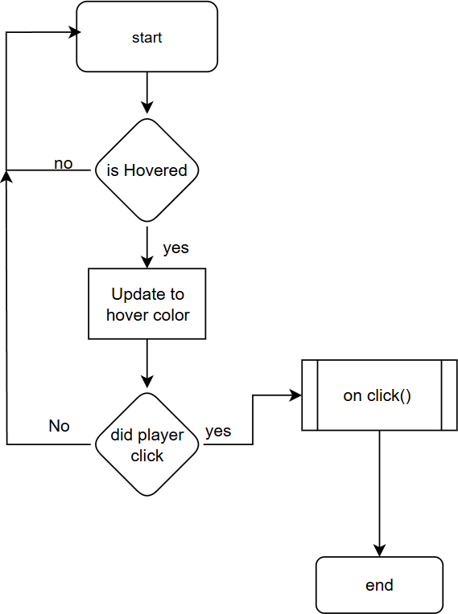

(See above for explanation regarding this flowchart)
USEABILITY FEATURES

GAME TUTORIAL
The purpose of having usability features is to make the game assessable to all players. For my game, this is important because of the varying demographic of stakeholders and players expected. For example, there are expected to be many younger players whom the game controls may not be intuitive. To address this, ensuring that these people have the best user experience possible, it will be worth developing a “help” button for the players to press with will open a menu that outlines the controls of the game. This will ensure that they know how to play the game. Below is an example of what this
“help” menu may look like taken from a random game.
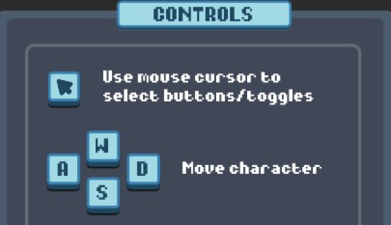
As you can see, this simple page that pops up when the user presses a button in setting called “Help”, outlines all the controls needed to play the game. This will be in lieu of a full-on game tutorial which has been deemed to be unnecessary by my stakeholders (shown below) due to the simplicity of my game. The controls shown in the help menu above are practically identical to the ones that will be used in my game and therefore my implementation will look very similar to this. Creating this menu will be done by utilizing the UIElements class and subclasses to define all the elements necessary for this menu (i.e. the labels saying “move character”) and then congregate into a single menu using the menu class. A command to load this menu can then be added to a button called “Help” which will be a part of the settings menu.
As the controls for my game are straight forward and logical, I proposed to my stakeholders the idea that a full-on game tutorial will not be necessary to explain them to the players. Instead, we decided that this help menu explained above outlining the controls will be satisfactory. Below are the results of a questionnaire given to them asking the question “Will a help menu suffice in explain the controls of the

game?” The stakeholders were given the choice to answer either: “Yes a help menu is sufficient” or “No I need more help knowing how to play the game”. The data collected from this is presented in form of a pie chart:
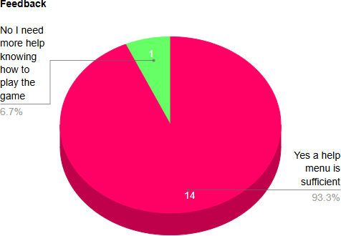

From this data, only 1 of the 15 stakeholders disagree that a help menu will be sufficient in explaining the controls, while most of them believe it to suffice. Upon following up with the one person who disagrees, they have explained that they have never played a PC game before and are native to Xbox and thus the controls of WASD are unfamiliar. I do not believe this to be a problem however, as I believe they will quickly pick up the controls, with help from the help menu, once they start playing and the confusion will no longer be there. I will also follow this in bata testing with another questionnaire to test this hypothesis when this feature is tested further.

PAUSING THE GAME
Another usability feature that is important to mention is the pause menu and the overall ability for the user to pause the game. This feature was inspired by my friend Faran Munib, my main teenager stakeholder, who has a problem with fast-paced motion games as they tend to give him migraines.
Playing Tomb of the Mask, being a very fast-paced game, is therefore understandability a challenge for him. The addition of a pause menu would allow Faran to take a step back from the game, if it were getting a little too fast for him, to recalibrate his eyes and take a break from the screen for a moment without him losing progress in the game. This would hopefully prevent him from having a migraine while

still allowing him to enjoy the game. By doing this, people like Faran can still have fun while playing tomb of the Mask despite his difficulties.
GUI LAYOUT

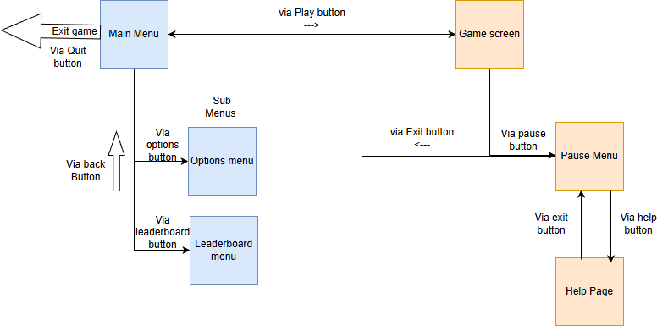

The diagram above shows the structure of the GUI and the routes of traversal from each menu. The game starts by loading the main menu. From here, the user could either: press the play button, options button, leader button or quit button.
If they press the play button, the game will start, and they will be greeted with the game screen. From the game screen, the player has access to the pause button which, when pressed, will temporally close the game screen and open the pause menu which pauses the game. In this menu, the player could either: quit to the main menu via the exit button, open the Help page via the Help button or resume playing via the resume playing button.
If the player presses the options button, the player will be taken to the options page where they can adjust the settings of the game. To return to the main menu, they must press the back button.
If the player presses the Leaderboard button, they will be taken to the leaderboard menu where they can view the leaderboard. To return to the main menu, they must press the back button.

If the player presses the Quit button, the game clock will stop, and the player will exit the game.
KEY VARIABLES
The variables that will be used in this section are shown and justified in the table below.

Name | Data Type | Scope | Purpose
X_pos | Integer | Local scope of UIelement class | This is located here for the user of inheritance for all UI elements and dictates the x position of a UI element such as  a label or a button.
Y_pos | Integer | Local scope of UIelement class | This is located here for the user of inheritance for all UI elements and dictates the y position of a UI element such as  a label or a button.
Font | String | Local scope of UIelement class  The same identifier is used for the same purpose in the local  scope of Button class. | This is located here for the user of inheritance for all UI elements and dictates the text font of a UI element such as a label or a button.
text | String | Local scope of Label class  The same identifier is used for the same purpose in the local  scope of Button class. | Denotes the text that will appear on a label.
Font_size | Integer | Local scope of Label class  The same identifier is used for the same purpose in the local scope of Button class. | Denotes the size of the font for a label.
Color | String | Local scope of Label class | Denotes the color of the font for a label.

Init_color | String | Local scope of Button class | Denotes the initial, non-hovered, color of the rectangle of the button. This is needed so that the program knows what color to set the button back after it is no longer  being hovered over.
Hovor_color | String | Local scope of Button class | Denotes the hovered color of the rectangle of the button. Needed so that the program knows what color to set the color of the button to when it is  being hovered.
width | integer | Local scope of Button  class | Denotes the width of  the button
Height | integer | Local scope of Button  class | Denotes the height of  the button
Text_color | string | Local scope of Button class | Denotes the color of the label used for the  button
Command_code | Function call | Local scope of Button class | Stores the call to a function so that each button object knows what to do when it is pressed. The function  that it calls process the buttons command.
Elements | Array | local scope of Menu class | stores all the UI elements that are native to a specific menu. I.e. all the  buttons, labels, etc.
Is_loaded | boolean | local scope of Menu class | This is used to switch menus on and off depending on which one needs to be loaded at a given time. This is True is the menu is loaded and False  otherwise.
Main_menu | Object | Global | The main menu.  Created using the menu class.

Optsion_menu | Object | Global | The option menu. Created using the  menu class.
Leaderbaord_menu | Object | Global | The leaderboard menu.  Created using the menu class.
Current_menu | object | Global | This holds the current menu that is loaded at a given time. This is needed to keep track of the menu that needs to be loaded in partnership with the attribute that  is_loaded.
ITERATIVE DEVELOPMENT TEST PLANS
This section outlines the alpha testing that will be done during development for this branch of the project.

Button Clicking and hovering test:
This test is done to check that each button will respond to the correct input that triggers its command and will hover at the correct time. Each button will be tested agist a normal entry that should be expected to trigger the buttons command and an invalid input that should not be expected to trigger the buttons command.
The valid/normal data will consist of hovering the mouse over the button and clicking in the middle of the button. This is normal data because it is the input that can be expected for most players to do when they are using the button. It should be expected to, without fault, execute the specific command of the button, and the button should change color indicating that it is being hovered.
The boundary data will involve hovering the mouse on the edge of the button hitbox and clicking. This is boundary data because it should just trigger the buttons command and is testing the boundary and limits of the button. The color of the button should also still change, indicating it is being hovered.
The erroneous data here is clicking outside of the button. This is erroneous data because it should not be expected to cause the buttons to command to be triggered or for the color of the button to change at all and is an incorrect user entry that should not do anything.
It is important that every button in the game is tested under these tests to prove the reliability of the classes and methods used to create them all working in tandem with one another.
The data from the tests can be recorded in the following table. In each category, the result of hovering over the button and clicking should be noted.

Button Name | Clicking in the middle  of the button | Clicking on the Edge of  the button | Clicking outside the  button
Play Button | Should start the game | Should start the game | Should do nothing
See Leaderboard Button | Should start the leaderboard menu | Should start the leaderboard menu | Should do nothing
Options Button | Should start the options menu | Should start the options menu | Should do nothing
Back Button | Should start the main  menu | Should start the main  menu | Should do nothing
In Game Pause Button | Should Pause the game  and open pause menu | Should Pause the game  and open pause menu | Should do nothing
Resume Player Button | Should close the pause menu and restart the game | Should close the pause menu and restart the game | Should do nothing
Exit to main menu Button | Should Exit the game  and stop the game loop | Should Exit the game  and stop the game loop | Should do nothing

POST DEVELOPEMENT TEST PLANS
This section outlines the beta testing that will be done during development for this branch of the project.
The success criteria that can be tested from this section fall under the user experience tab and include the following listen below. These will all be tested after my bata testers, my stakeholder, play a rendition of the game.

Ease of navigation:

Survey with stakeholders where they will rate how easy it is to navigate the main menu on a scale of 1-10, responding to the question:

“On a scale of 1-10, how easy was it for you to navigate the main menu and any subsequent in game menus? Where 1 represents it being hard and 10 being very easy.”

The menu must be responsive:

Here, each button must be tested to see how fast they respond using the pygame
internal clock and break points. To pass, they must respond in under 150ms. The test plan is shown as a table below:

Button Name | Response Time | Pass/Fail
Play Button
See Leaderboard Button
Options Button
Back Button
In Game Pause Button
Resume Player Button
Exit to main menu Button

The menu must be functional:

Survey to stakeholders in which they rate the functionality of each button on a scale of 1-10. Responding to the question:

“On a scale of 1-10, did each button do what you would expect it to do given its label?”

1.1.3 Visual feedback when navigating the menu:

Survey given to the stakeholders who have used the menu to determine (on a scale of 1-10) the effectiveness of the button hover color and the ability to track the cursor. Responding to the questions:

“On a scale of 1-10, did the menu feel dynamic and was the cursor easy to follow?”

This can also be tested in alpha testing by testing if the hover mechanic works for each button. A table of results can be constructed to show this data as shown below:

Button name | Did the button change color when hovered?
Play Button
See Leaderboard Button
Options Button
Back Button
In Game Pause Button

Resume Player Button
Exit to main menu Button

1.2 The game opens with a splash screen:

Yes/no stakeholder survey where the stakeholder identifies if a splash screen is present when they load the game or not.

1.3.2 Difficulty scaler:

The usability of this feature will be tested with a survey given to stakeholders (answering yes or no) where they can determine how easy it is to use the feature. Responding to the question:

“Was the ability to change the difficulty of the game made obvious and easy to use.”

The functionality of this feature can be tested with another survey, responding to the question:

“On a scale from 1-10, how effective did you think the ability to change difficulty of the
game was?”

1.5.1 Consistent Visual Style:

Survey to stakeholder where they will rate the overall aesthetic of the main menu on a scale of 1-10. This will be done by responding to the question:

“On a scale from 1-10, how consistent and thematical was the design of the main menu?”

LEADERBOARD AND DATABASE

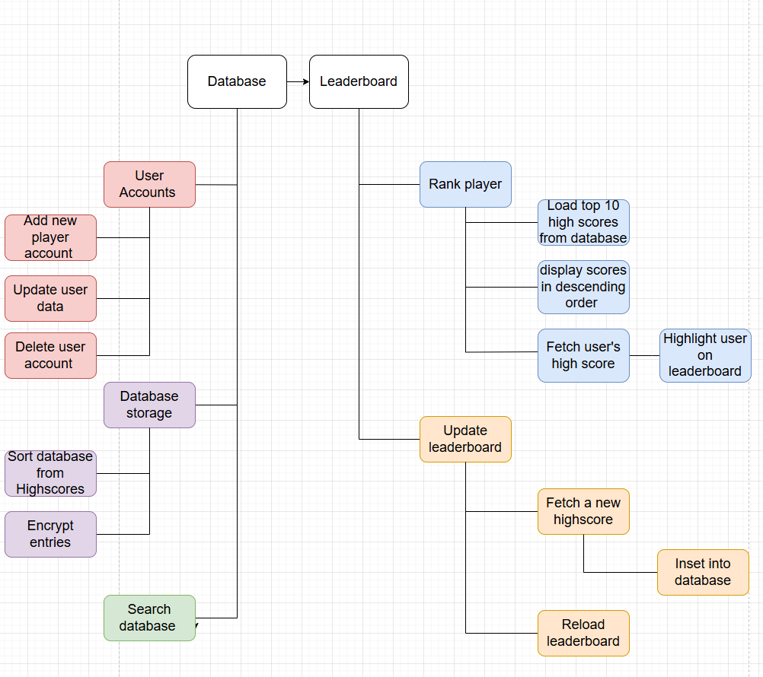

I have broken down the “leaderboard/ Database” section into 5 key aspects: User Accounts, Search database, rank player and update leaderboard. I have grouped these together because the leaderboard functionality is primarily drawn from the database functionality while the database functionality is sourly for the leaderboard. In this way, it would be impossible to do each section individually without referencing the other excessively and ultimately confusing the reader.

DATABASE STRUCTURE

The database will store the following data about the user: username, password, most recent score, and high score. To maximize the efficiency and speed of the database and reduce redundancy, a relational

model will be implemented instead of a flat file model. The structure will use a single table structured in the fallowing manor with an example record loaded into it:

User_ID | Username | Password | Recent_score | High_score
0 | Dan_the_man | “Hashed  password” | 123 | 333

The reason a relational database is faster than a flat file one is because it uses a hash table to access specific records with a constant time complexity instead of a linear time complexity that would otherwise be used to search the database. This is done based on the primary key – in this case User_ID highlighted in red above – and will be handled enterally by the database software I'm using called
“MySQL.” This is where the database will be hosted, and it will be hosted on my local computer. This is obviously a limitation as it means that the database cannot be accessed on any other machine other than mine as to access it the program will pull from a server on my computer. However, if I were to correct this it would require me to purchase a database server or open a port on my firewall which is not in the scope of this project, so the limited approach outlined is the best alternative as it shows proof of concept. Moreover, the leaderboard, whilst important, will not be necessary to run the game. Instead, there will be a precheck that the user has access to the database (i.e. the game is running on my computer and has a connection to the database) and will then give the user access to the leaderboard functionality. However, if there is not a connection established, instead of crashing the game and giving an error, a try and exception statement will be used for this as to not cause the program to crash.
A simple way to do this multiple times within a program is to create a function which returns true if a connection is established, thus allowing the game to use the leaderboard function, and false if a connection is not established. This function will be called upon when the leaderboard button is pressed. I am doing it this way to allow the user to still be able to play the game and not have it crash when they do not have access to the leaderboard. This also allows the player to use the leaderboard if they are playing on my computer to show proof of concept. Below is a pseudocode representation of how this try except function will look:
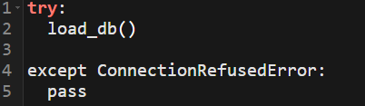
As you can see, the program initially tries to call the function load_db() which attempts to establish a connection between the SQL server on my computer and the game. If there is a connection created, no

further action is required. However, if the program fails to connect for whatever reason, then a specific error is returned, the “ConnectsionRefusedError.” The except statement will listen for this error and if it is flagged it will not crash the game, instead it will just except it and pass. In the feature, additional logic can be added here instead of a simple pass statement to let the main program know that no connection has been established and to not allow the leaderboard to be loaded. This will present the user with a page that says something along the lines of “Seems like you can't access the database right now.” Then it will redirect the user back to the main menu. Instead of a pass statement, a variable did_connect could be created that will be set to False which will change the menu screen.

LEADERBOARD DATA COLLECTION
For the leaderboard to display all the necessary information (Username of top 5 users and their respective high scores) the database must be able to be searched for the specific top 5 users. This will involve an SQL statement that selects the usernames of the top 5 users with the highest scores. In Python, this can be done by using the execute function from the MySQL connector library where the database is molded as an object and changed are made to that object before committing them back to the database. Below is an example of the SQL statement that will be used to collect the relevant data needed to display the leaderboard.
This code will return all the usernames and high scores of every player in the database in the form of an array consisting of tuples – like this: [(username, high score), (username, high score)]. The array will be pre-sorted by high scores, where index 0 represents the player with the highest high score. This is done by the SQL command “ORDER BY high_score DESC” which understandably sorts all entities in the database by the value of the high score in descending order. This makes access to this data incredibly easy and allows me to obtain the top 5 players for the leaderboard simply by running a for loop that iterates through the array stopping once 5 iterations are obtained, as shown in the pseudo code below:

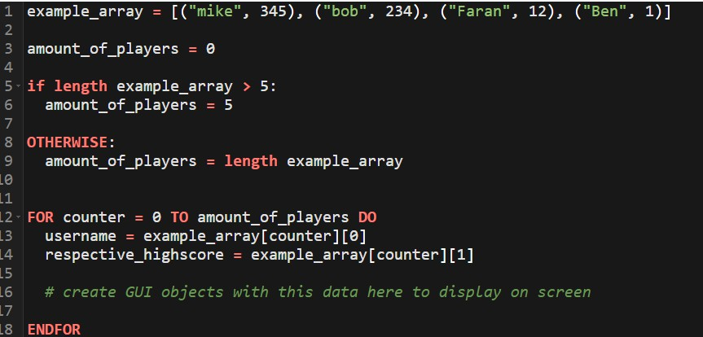

In this algorithm, there is an array called “example array” which is assumed to be the output from the SQL statement described above. In this array, there are 3 instances of players' usernames and their respective high scores indicating that the database has only 3 records in it. This is important to note because if the databases contain less than 5 records, when iterating through the array to get 5 names for the leaderboard, there would be an index out of range error. To correct this, a variable amount_of_players is defined, whose value is determined by the length of the array. If the array has less than 5 instances, then the number of players that will be displayed on the leaderboard is the length of the array, or in other words, the total number of players in the database. In this instance, where the length of the array is 3, the number of players on the leaderboard will be 3. If, however, there are more than 5 players in the array, then the length of the leaderboard is capped at 5. This is done to avoid an index out of range error as mentioned before and can be seen in the pseudo code above from line 3-9.
From here, count-controlled iteration is used to extract the usernames and respective high scores from all the users to be displayed on the leaderboard. The variable counter, seen in the for loop on line 12, represents the index of the array that is currently being visited and thus the progression of the for loop through the whole array. If, at an instance, the value of counter where to be 1 than the value of example_array[counter] would be (bob, 234), assuming zero indexed arrays. In essence, doing this is singling out a particular player and their high score from the array of players and high scores. From here, if you wanted just the player username from the tuple, you would call for the zeroth index of the tuple (bob, 234), which would output bob. Likewise, if you wanted the player’s high score, you would call for the first index of the tuple (bob, 234), which would output 234. Putting these two together, we get the line username = example_array[counter][0] to extract the username per instance in the array and the line respective_highscore = example_array[counter][1] to extract that player’s respective high score.

From here, still within the loop, multiple UI elements can be created for the leaderboard. This involves a discrete label for each player’s username and high score which can be drawn onto the screen at different positions to be aesthetically pleasing.
WRITING PLAYERS HIGH SCORES TO DATABASE AND SEARCHING DATABASE
It is important to note that throughout the execution of the program the contents of the database will be molded as a 2-dimensional array (as shown above) so that access to player data can be done easily and efficiently. This means that accessing the player's high score has a constant time complexity once the user's unique id is identified as; the user's ID represents the location of the data in the database. However, if the array is sorted, this will not be the case. To search for a specific instance, given that they are not ordered in terms of User_ID, a linear search algorithm can be used. This is shown in the pseudocode below:
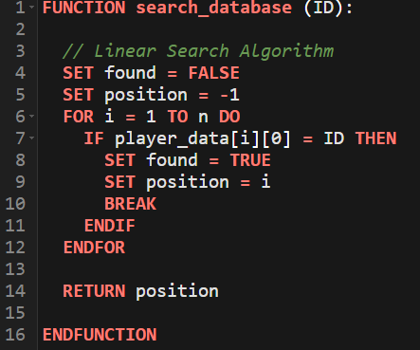
This pseudocode shows a linear search of the array: player_data. It searches for a unique instance of the player’s User_ID which is taken as a parameter. A variable Found is initially set to false and indicates if the instance has been found or not while the variable position, initially set to -1, indicates the position of the desired instance. The program will then iterate through the array comparing each element‘s user ID to the desired ID until there is a match. If they match, found is set to True and the position is
set to i, indicating that the position of the element in the list is at the current point of iteration through the for loop. The function then returns this value to be used for quick reference elsewhere in the program. It is important to note that, as player_data is a 2D array, player_data[i][0] represents the user_ID of that element at that iteration through the loop. Moreover, this must be done on only primary keys, ensuring that there is only one instance that can be referred to. Also, if the program doesn't find a match, then the function will return -1 indicating that the user is not in the database.
After the player plays a game, they will receive a score. This score will be saved under the variable recent_score. If a recent score is higher than high_score, high_score is set to recent_score and immediately written to the database. This is done immediately so that it is ensured to be noted and not lost. These two metrics will also be on display in the main menu for the user to see. The player’s

recent_score however, only gets written on the database when the game closes as the only point of this metric being in the database is to save their scores between sessions.
LOGING PLAYER IN AND REGISTERING NEW PLAYERS
The point of this section is to allocate the correct user account to a particular instance of the game. If the user is already registered, this will involve simply logging in and storing the Users name as a variable. If the player is not already registered, then they will be prompted to create an account and then redirected to the login page to log in with the account details just created. This is the way that most of the registry systems in the world work.
These systems will be created using the TKinter library for the register/login GUI. This is done to keep the logic separate from the main game and GUI mechanics as they involve different elements which will be time consuming to implement. Moreover, TKinter is much easier to use. Simply, when the user presses a button in the pygame window, a TKinter window will be created with the prompt to enter a username and password. These entry fields will then be checked against the database essentially creating a composite key, and if there is a match then the username will be returned, and they will have successfully logged in. If the username and/or password do match, then the user will not be granted the functionality of the leaderboard. They will then be given the opportunity to register where they can enter a new username and password. The flowchart below shows this system:

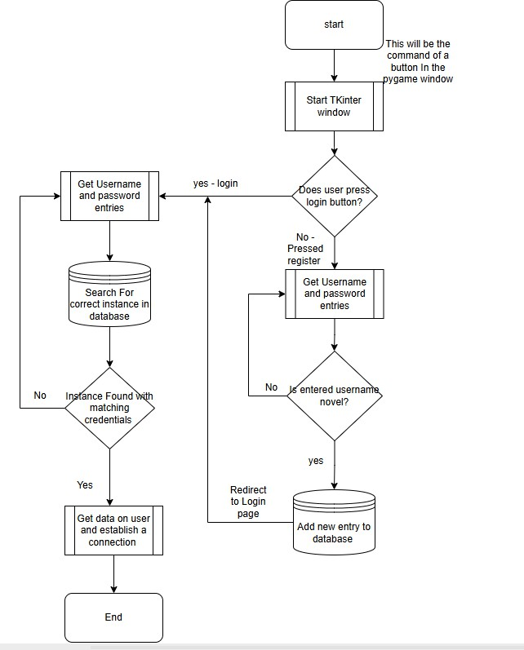

The above diagram starts when the user presses a button in the pygame window that says something along the lines of “Login.” When this button is pressed, A Tkinter window is created with 2 entries that say username and password with a button that says login on the bottom. There will also be a button that says “Don't already have an account? Register here.” The diagram presents a decision where if the user presses register or login, the program takes two different routes.
If the user presses the Login button, the data in the username and password entries will be sent to the main python program where they will be searched in the database via the search database function, which is explained in more detail in the section above. If there is a valid instance with the same username and password, the search function will return true, and the user will be granted access. The associated primary key will be stored in a variable once a connection is established. This is so that in the

feature reference data can be extracted easier and with constant time complexity. If the program does not create a connection, then the user will be met with an error message saying, “Username and/or password are not correct” and the user will be redirected to the login page.
If the user presses the register button, the entire data will be first checked if the instance is already in the database. This will ensure that the users can only be limited to one novel username per database and will hopefully deter people from spam creating multiple instances per user which depletes database storage. The data will then be inserted into the database via an SQL link function. It is important to note that the database will be autoincremented so that the primary key will auto increase when a new entry is added. Once this is done and the user has successfully registered, they will be redirected to the login page to then login to the account they just created.
The SQL statement that will be excited to put an instance in the database will be as follows:

The above SQL statement will exist within a function called register player which takes values of username and password from the username and password entries as parameters and inserts them into the database. This also inserts 0 for both the player’s recent score and high score as with a new account they will not have any data on them. However, if the player were to play a game, then registry after that this score will not be included in the database. To account for this, it should be done that before the user closes the game, the values of the recent score should be appended to the database so that the data will not be lost.

TEST PLANS – FOR DATABASE FUNCTIONALITY/ LEADERBOARD INTEGRATION

Feature/Subroutine | How to test it | Expected outcome | Justification
Connecting to database test function | Test by first trying to connect to the database by running the subroutine try_db() from my computer and then from the computer at school, which does not have access to the database on my computer. | When running the function that connects to the db from my computer, the function should return true, and a valid connection should be established. If the program is running from a computer outside of my computer, the function should return  false, and the program | This is tested because the server I’m using for the database is hosted on my computer and will not be able to be connected to unless it is running from my computer as I will not be opening a port. This means that if a player tries to play the game on a computer that is  not mine, they will not

 |  | should not crash. There should be no error raised from the program not being able to make a connection. | be able to access the leaderboard feature. Instead of this crashing, it must be ensured that the game handles this adequately, hence the program returning returns False instead of  crashing.
Collecting Data from database for the leaderboard. | From my SQL workbench, I will manually insert a three-test entity into the database with example usernames, passwords, recent scores, and three different high scores. Then, I will run the  Subroutine with a print statement to check what the program has collected. | I would expect to see a 2D array output into the Python console with the test entity in a tuple. This should be like this:  [(user_id, username, password, recent_score, high_score)]. There should be three entities in the Array, and they should be in order of high score descending. For example, Jhon with high score 5 should appear at index 1 where Dan_the_man with high score 67 should be at index 0 in the array. | This data that is outputted from this Subroutine will be the foundation upon which multiple other Subroutines are based upon. Therefore, it is important to confirm that it is working correctly and outputting the expected data in the correct order. This is why there must be three different test entities entered into the database with different values for their high scores to test that the ordering command is functioning correctly.
Leaderboard displaying | Using the same three test entities, I will test that the leaderboard menu displays the correct number of users as are in the database on the leaderboard and that they are displayed in the correct format: rank, Username, respective high score. The high scores must also be in the correct  order, descending. I will then iterate from | For each number of entities inserted into the SQL database manually, the correct number of entities should be on display in the leaderboard with their respective high scores in the correct order. For example, if there are 3 users in the DB then there should only be three users displayed in the  database. If there are more than 5 users in | This test is done to ensure that the correct number of users will be displaced on the leaderboard and that the data on the leaderboard is accurate and up to date. By testing every possible combination of the instances that can be on the leaderboard, it will ensure that there are no faulty situations  that will crash the game or leader into an

 | 1-5 test entities in the database and test that the correct number is displayed for all the Aswell. | the database, then there should be no more than 5 users displayed on the leaderboard. | incorrect leaderboard being generated.
Inserting into the database | I will run the registering function with a test username, password, recent score and high score. I will then see that the program had successfully inserted the test entity into the database by opening the MySQL workbench and checking the table  for the inserted data. | Upon running the function and opening the MySQL work bench, I should be able to see the test entity present in the database at the next location in the autoincrements. | This is tested because it will ensure that the user is able to register correctly and that it is working correctly. If the user puts their credentials into the program, they should expect them to be sorted adequately in the database.
Loging in users and storing their respective user ID | This is tested by creating a test entity with known username and password and inserting it into the database and logging into it via the login function by putting in the exact known username and password. As they appear in the database, there will be a temporally print statement that will be used to see if the correct user ID has been identified and matched to the instance. This will test that logging in works correctly. I will then knowingly input the correct username and wrong password to check that the program denies access to the  account. | When the correct username and password are inputted, the program should print the correct userID of the instance which can be validated by checking the known user ID from the SQL workbench. If the username and password do not match the expected, the program should clear the entries and output a message which says, “incorrect credentials” and not account link should be established. | The point of testing this is to ensure that the program creates a valid and correct link between the database entry and the current user. A valid matching user ID will confirm that this link has been made successfully.  Moreover, there should be no like made if the user provides the wrong credentials as this would allow for unauthorized access to a player's account, which is not ideal.

KEY VARIABLES FOR DATABASE AND LEADERBOARD

Name | Data type | Scope | Purpose
db | Object | Global | This is a variable that stores the connection object between the program and the database. This will be made globally and declared in the try_db_connectsion() function as to not have a repeated connection with the database as this will quickly impact performance of the game. Therefore, by having one centralized connection it  will reduce program redundancy.
Cursor | Object | Global | This is like db and in fact created from db as it is the cursor which is used to navigate throughout the database via SQL statements. The reason for creating this globally is the  same as db.
Db_leaderboard_data | Array | Local scope of create leaderboard menu objects | This array stores all the players high scores and usernames in an array of  tuples that is returned

from the collect_leaderbaord_data() function. Iterating through this sorted list 5 times will thus yield the top 5
player’s high score and their username from which can be used to create menu objects in the
leaderboard menu.

PLAYER MECHANICS

PROCEDURAL GENERATION

OVERVIEW

The goal of procedural generation is to create a unique, random feel for the game every time the player plays it. It also makes the game infidelity playable without the need for me to create levels by hand.

An illusion of randomness can be created by randomly pulling from a bank of predefined different “segments” and stitching them vertically together to create a “zone.” A segment is an area of variable length (depending on the segment) which is hand crafted to be completable and entertaining. A zone consists of a few segments' places vertical one on top of the other in a random order. The game only loads one zone at a time, and at the end of a zone there is sort of a cut scene where the program loads the next zone while the previous one is being unloaded.
The program will start by randomly pulling from a JSON file a variable number of segments to create one zone. The number of segments it will pull will be dependent on the difficulty scaler. A difficulty of easy will mean only 3 segments per zone, medium will mean 5 and hard will mean 8. This will vary the length of the zone and thus how hard it is to complete.
As the player is traversing through the maze, the Moster, Larry, will be chasing the player. The monster's speed will also be determined on the player's set difficulty where a higher difficulty will correspond to a faster speed.
The decomposition chart below shows how I plan to split up this section of the project. It was done in this way so that modularity can be achieved as the section in the chart ruffly corresponds to the structure of the solution where each heading will be its own script. This also helps to check the problem into tangled goals that will increase development speed.

1
l
PRCEDURAL
GENERATION
Maipdesign
,,
Spawn se�ents
.
1
Le�el segments
,
I
ge:nerati g zo es

Scrolli g camera

Speed up over lime
,
Tra.nsitian segmE!flfs

Queue of pla�ers mo...-emenls

tD'.flster chacing
player

SG.3le wilh difficulty

Spawn zom!s·n corrctspot
l_ J

MAP DESIGN

TILE SET

The map design will be done in a program called Tiled. This software allows me to create 2D flat maps with different layers that the player can interact with via a python library called pyTMX. The layer can either be a tile layer (which is reserved for static parts of the map with simple collision logic) or an object layer (which is reserved for non-static parts of the map that require special collision logic.)
There will be a different layer for the walls, spikes, background, and coins on the map I will design. The wall layer will be a tile layer as it will be static same as the background layer, and the only collision the player has to do with it is simple rect collides with the wall layer. The spike layer will be an object layer with special proprieties and variables, which kills the player. This is the same for the coil layer which will have the special collision detection which increments the score by one.
Each entity (walls, spikes, background, and coins) exists as a tile as part of a tile set. A tile set is a complete collection of all the tiles that are present in the game. Each title is 32x32 pixels; this is the stander size that the software recommends. This also works well with the dimensions of the game as the screen is 1280x704 pixels which neatly fits 40x22 tiles. A picture of the complete tile set is shown below, which were created by me in a pixel art software called pixels:

This is a wall tile. It will be on the wall_layer and it is what the player will collide with and sand on. The reason it must exits on a different layer than the background layer is because the player must be able to collide with this layer but not with the background layer and grouping them together will make it impossible for the program to tell which is which.
The properties of this layer, as outlined by the software, are shown below:
As you can see, the wall_layer is a Tile layer with custom boolean property: collision, which is set to true. This may end up being redundant however as when I start to program collision between the sprite and

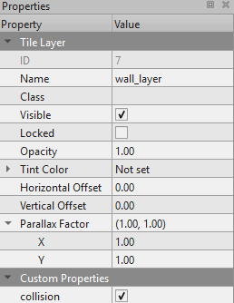

the walls, I may not deed a dedicated variable. However, just in case I have attached it to it so that the program definitely knows that the player is able to collide with this tile.

This is the background tile and will exist on the background layer. It is just straight black as you can see and will make up most of the map. The player will not be able to interact with this tile, so there are no custom or special layer properties attached to this tile. I must create a dedicated background tile instead of simply having a black screen with the map loaded on top of it because I believe it will be easier to just load the map as a whole and not bother about a screen as well.

This is the coin object and will exist on the coin layer. These will be placed throughout the map and, when touching a player, will increase the player's score by one. This special collision logic is why it must exist on its own object layer and not simply a tile layer as tile layers do not allow for the addition of special properties.
The properties of this layer, as outlined by the software, are shown below:


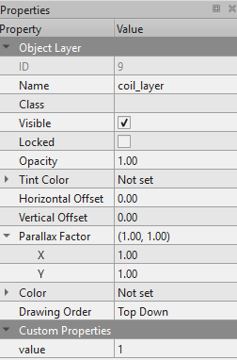
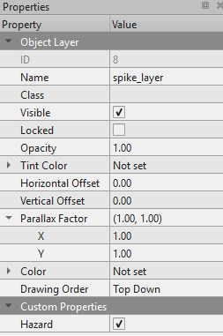
This object layer has a special property called value, which is set to one. This will tell the program that when the player collides with this coin, the score will increase by one.

This is the spike object and will exist on the spike layer. These will be placed throughout the map, and when the player collides with one of them, the player must die. This special collision logic, much as with the coil, is why it mustn't exist on a tile layer and why it must be on an object layer.
The properties of this layer, as outlined by the software, are shown below:
This object layer has the custom boolean propriety called Hazard, which is set to true. This will tell the program that if the player is to collide with this object they must be killed.

SPAWN SEGMENT

As I have mentioned in the overview of this section, different segments will make up a zone. Each zone must have a spawn segment where the player is initially placed. I will be creating just one spawn segment that will be placed at the start of every zone to reduce time spent on map development and priorities other important aspects of the game. The spawn segment must have a place/platform for the player to spawn on, and the top must be open so that it can connect to the bottom of another segment. The spawn segment that I have created is shown below:

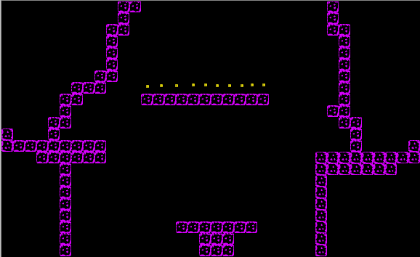

It is also important to note that there will be an invisible spawn tile in this segment. This spawn tile will provide the coordinates for which the player will spawn on. The reason it must be done this way is because the tiled maps coordinate system is profoundly different to the screen cordate system.
Therefore, I would not be able to stipulate the exact spawn location for the player by reference of a screen coordinate and would instead have to reference a map coordinate. This is where the spawn tile comes in handy, as I can reference its coordinate within the map and place the player on that coordinate reliably.

LEVEL SEGMENTS:

I will be creating 5 others supplementary segments for the game to pull from when procedural generating the map. This is a mundane task and the only parameters that must be followed are outlined below:
. There must be at least one definitive completable path for the player to take to exit the segment.

. It must be open at the top and bottom of the map to allow for easy stitching of the segments when they come together. This is because the order in which it will be stacked in unknown and random each time it is generated, so it is impossible to predict which segment will come next in the sequence.
Therefore, to ensure there is a completable path between segment transitions, there should be an open row of tiles at the beginning and end of each segment.
Nine examples of the supplementary segments that will be used are shown below. These are screenshots from the actual game Tomb of the Mask, and my segments will be heavily inspired by them.
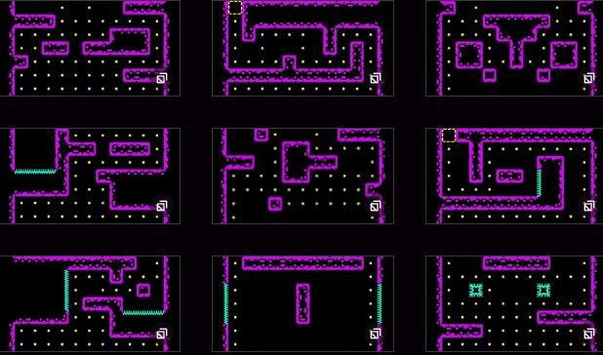
As you can see, each segment shown here has a fully open bottom for the reasons outlined above and has at least one opening at the top for the player to emerge from and then to enter the next segment. There are also spikes scattered parodically throughout the segment positioned in such ways to make the player think about their next move through the level.

TRANSISTION SEGMENTS

A transition segment will exist between two zones to make the transition between the zones smooth and negate the time it takes to load the next zone. This is so that the player appears to never stop moving and thus concede with the bounds of continuous directional movement until collision, otherwise there would be a noticeable hiccup between the zones where the player stops moving as the next zone is loaded. This hiccup would be exacerbated on lower end devices.

The design of these transition segments is straight forwards and simply are just open spaces where the

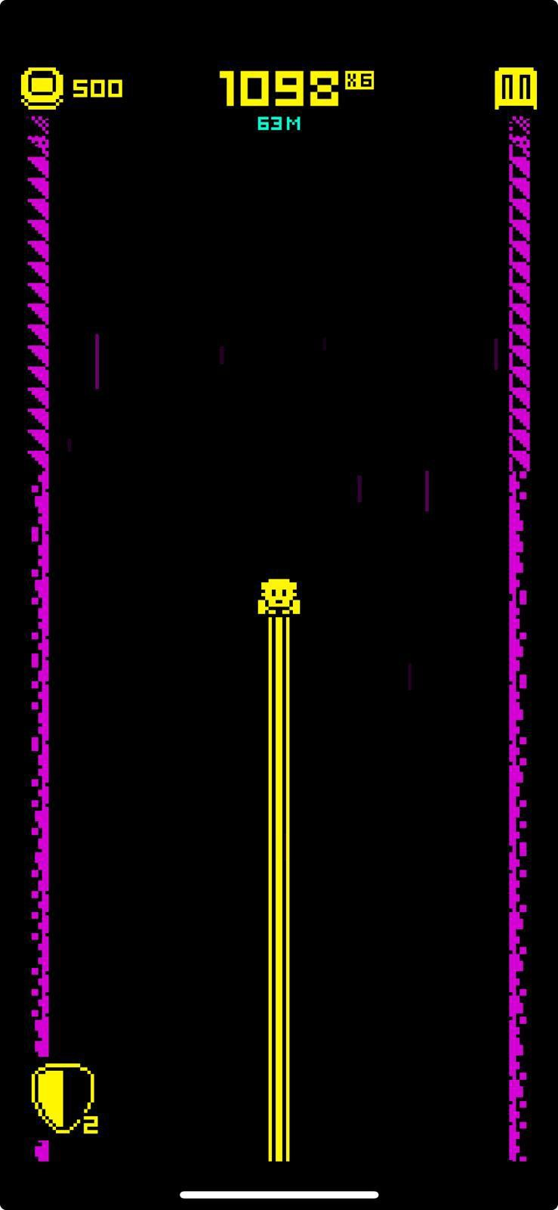
player appears to be moving vertically upwards endlessly until the next zone is loaded and the player “lands” on the spawn segment of the next zone. This is shown to the left, taken from a screenshot of the official version of Tomb of the Mask.

LOCATING SPECIFIC TILES AND OBJECTS FROM THE MAP FILE

Essentially, the map is stored as an encoded array in the TMX file. Here, data about each tile in each layer can be found by first decoding the data, then iterating through an array to find a specific tile/object. This logic will be used for all collisions in the game.

WALL AND SPIKE TILES

This section deals with finding the collision rects for walls within the map and not with the actual collision logic behind the player-wall interactions; this will instead be discussed in the player-mechanism section of this document. The point of collecting the wall-rect data so is that the player class has a record of where all the walls are, so it knows how to handle collisions.
Thus, to provide this data, we must first filter through the encoded TMX file and pull out the relevant x and y coordinates for all tiles which are in the wall_layer. From here, a rect can be given to each wall based on these coordinates and the width of the tile, and then it can be added to a list of all the other wall rects. The point of sorting them as a list is so that they can be quickly accessed in the feature by any class, such as the player class.
The flow chart below demonstrates this logic explained above that will be in a function:

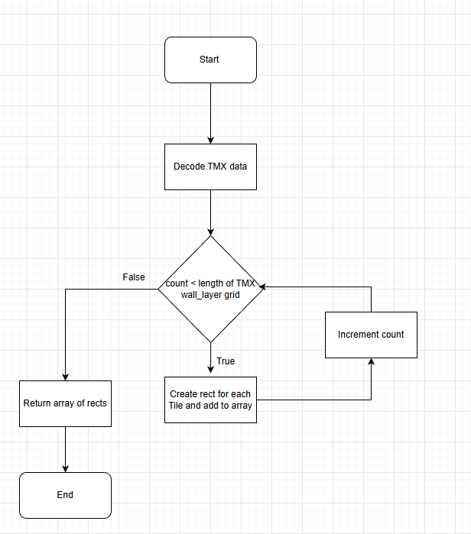

This function will be called at the start of the game when all other assets are being loaded for every segment that could possibly become loaded. It only needs to be called once because the position of these rects will not change throughout the duration of the game. Creating a CatLog of rects per segment is important because it will make the transition between segments within zones feel smooth as it will not be calculating all the positions of all the walls each time. To make this work, however, it will require the rect array to be stored in forms of a 2D array where data about which segment the rect belongs to and the rect data itself. This is because if the player is checking for rects that are not actually loaded at the given segment but are in the rect array it would lead to phantom collisions where it would appear as

if the player is colliding with nothing but in fact it is just a rect from a different segment that are all being loaded at once.
It is important to note that the spike tiles will be handled in the same way as the wall tiles in this section, and the only difference between the two happens with how the player interacts with both, where colliding with a wall will prevent further movement in that direction, collision with a spike tile will kill the player.

COIN TILES

Each coin will be molded as an object created from the coin class which will inherent from the pygame.sprite.Sprite class as to be added to a group of sprites later for ease of centering with the map. The UML diagram below shows the structure of this class:
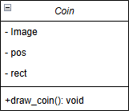
This is a simple class that only has three attributes: Image, this will be the image of the coin which the rect will be based upon.
Pos, this is a pygame vector which represents the coins in relative position in relation to the map. It will take the x and y position of the coin tile within the TMX data via the same algorithm shown above. Once the coins position has been determined within the TMX data array, it must then calculate its relative position within the map. This is done by multiplying both the x TMX data coordinate and the y by the width of the tile.
This is because the coin’s x and y position takes the coins location within the TMX data array which is an index of every tile and not representative of the real-world map coordinates. By multiplying the width of each tile, it will give its location relative to its position on the map. It should also be noted that this process is needed for the location of every single tile on the map and is part of the decoded TMX data shown in the flow chart above.
Now that the coin knows its position within the map, via this pos attribute, it is now given a rect and by the inbuilt pygame method and assigned to the attribute rect.
The method of drawing coins is very simple. It will simply blit the coin onto the screen given the attribute image and rect. This is the only feature of the coin as the coin collection and player score logic will be handled by the player class.

Now that we have a method to create coins, we must create a coin and place it at every location on the map where there is meant to be a coin, indicated by the TMX data. First, the algorithm to locate all the coins position within the TMX data is called. This algorithm will then create a coin object for each tile where it finds a coin and adds it to the pygame sprite group. The point of adding it to the group is that they can all be updated and drawn at once. Moreover, it will all be for the pos vector of the coin to match up with the camera offset which is centered on the player. This allows for the screen to move relative to the player’s position in the map without the coin’s position moving, otherwise, they would appear to follow the player as they move throughout the map. In addition, to stop drawing the coins, thus, to make the coins disappear when collected, it would be as simple as to remove them from the pygame sprite group. The simple flow chart below illustrates this perfectly.
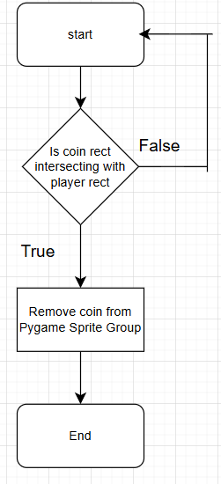
As you can see to the left, this checking algorithm, which will run within a for-loop iterating through every coin that is drawn on the screen, starts by checking if the coin rect is intersecting with the players rect. If the rects are interesting, then it can be said that there is a collision between the two objects, and the coin must then be removed from the group and thus it will disappear. If it is not touched, it will constantly check the condition throughout the duration of the program in the main game loop. until it is touched or it is unloaded. This is a very archaic way for checking coin collisions however it would be very hard for the processer to check every single coin ever single clock cycle.
However, for this implementation it will be adequate as there are not many other objects that need to be loaded in the game, so it will not adversely affect the performance of the game and should not dramatically tank FPS. A better way of doing this would be to chunk the screen into 32 different segments and only check the segments that they player is currently in for coin and/or wall collisions as it is only possible for the player to collide

with objects are in the segment it is in. Therefore, effectively improving performance 32x in theory. However, this implementation would be far out of the scope of the projects and is merely a suggestion to optimize the game.

SPAWN TILES

The spawn tile is very important as it sets the coordinates where the player will start on the map. The search for this tile within the TMX data is very similar to search for the other tiles but instead of it being a tile layer it is an object layer. This makes the search much faster as there are far fewer object layer tiles than tile layers, so it has fewer items to iterate through in the worst case.
Once the spawn tile position in the TMX data array has been determined, the same logic from the wall and coin tiles is applied to find its relative position within the map. It then is drawn onto the screen in that position. But it will blend into the background as it is an invisible tile that the player is not intended to see. Now, the Players' start coordinates can be set using the coordinates of this tile. The reason this must be done like this is because there is a discrepancy between the traditional screen coordinates for dawning objects and the map coordinates. This means that If I wanted to spawn the player at 0,0 by stipulating screen coordinates it would not spawn the player at 0,0 relative to the maps starting position, Therefore, to ensure reliable positioning of the player, map coordinates must be used.

GENERATE ZONES

Each zone will be made of a certain number of level segments depending on the preset of the difficulty slider, which is subject to change dependent on stakeholder feedback. For sake of argument, assume that the easy preset consists of 3 level segments, medium has 5 and hard has 7. The order of these level segments will be random and the design of each segment, discussed in detail above, will ensure that no matter the arrangements of the segments there will always be at least one completable path for the player to take. At the end of a zone, there will be a transition segment and at the start of the zone, there will be a spawn segment. The structure of a zone is shown in the diagram below:

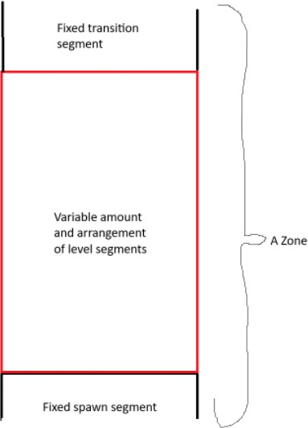

generated and loaded.
As you can see, the top and bottom of the zone are open to allow for the stitching of an infinite number of zones as the player thyroidally progresses infinitely through the labyrinth.

It is important to note, however, that only one zone will be loaded and generated at any given time, the zone which the player is currently in. This means that the arrangement of the next zone will not be determined until the player reaches the transition segment of the previous zone.

This is to reduce the strain on the processor and allow for the game to run smoother on any device. This is also the reason why transition segments exist, as explained in detail above, to prove a buffer while the next zone is being

Once the player reaches a transition segment, the next zone will be generated taking the level difficulty preset mentioned above as a parameter while the previous zone is unloaded, again to reduce strain on the processor.

CAMERA SCROLLING

The camera scrolling logic will be handled entirely by the library Pyscroll. This works by centering the player in the middle of the map and only loading the section of the map at a given time where the player is current at. Thus, the player always appears to be in the center of the screen while the map moves around the player. This gives the illusion that the player is moving through the map while in actuality the map is moving relative to the players' fixed position. This is a very common technique used within two-dimensional arcade-style scrolling games.
Pyscroll works by first initializing a map which can be rendered onto the screen using library methods. The issue with this is that each segment is stored in its own TMX file and is not in one continuous map which Pyscroll needs to initialize. To fix this, a temporary zone TMX file can be created before being initialized in Pyscroll which stores all the constituent segments stitched vertically together. Thus, instead of trying to initialize and render all the individual segments, it can be done once by loading the concatenated zone file. There will also be a dedicated tile located only at the start of the transition segment which, when the player touches, starts the loading process of the next zone and when the player reaches the end of the transition segment gets teleported to the spawn segment of the next zone. This will make the game feel infinitely looped while the player is just moving through one constantly regenerating file. The camera will also constantly be adjusted within the zone file to be centralized on the player the whole time.

RISING LAVA OR CHASING MONSTER

The main thing that makes the game hard and enjoyable for players is the constantly increasing time pressure. This is caused by escaping rising lava in the original game or the proposed Moster chasing the player in my version of the game. Both will be suitable for creating the needed time pressure but in the analysis section i discussed the potential limitations of using rising lava, notability the fact that the screen is wider than taller so it may appear stange looking to the player. However, upon further consideration I feel that this will not be as big as a problem as anticipated, so the rising lava option is now a viable one. To choose, I will conduct a stakeholder survey asking which they prefer, and that will be the one that is discussed in this section. The results to the survey are shown below:
Question: "Which method of time pressure creation do you prefer, rising lava which if the player touches you die like the lava in the official version of Tomb of the Mask or a sort of Moster that chases the player copying their every move and if touched killing the player, like the man that chases the player in Sub Way surfer?”
From this chart it can be seen that of the 16 stakeholders whom I asked the question to, 11 of them voted for the lava and only 5 voted for the Monster. From this, it can therefore be concluded that I will be implementing a rising lava feature over a chasing Moster feature.

The lava will start rising after a time delay from the players’ first input, and the rate of rising will

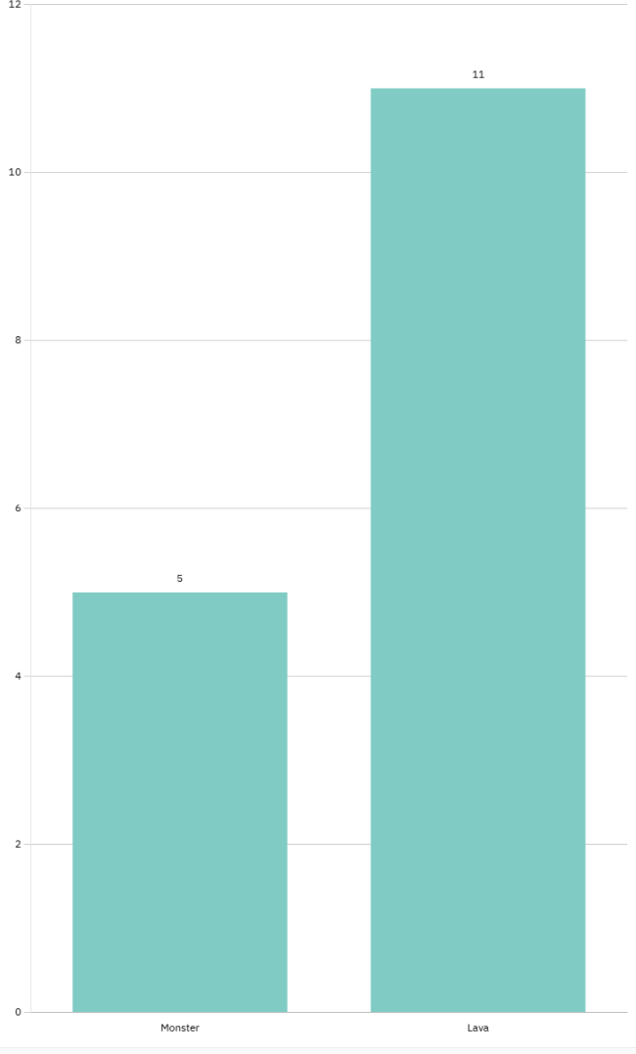
accelerate as the player’s survival time increases. However, there must be a hard limit at which the lava’s rising speed is capped at as otherwise it would make the game impossible past a certain point as the player could not physically escape a zone before the lava kills the player.

LAVA MECHANICS

The lava will simply be a rectangular red/orange sprite with a variable vertical size. It will have a fixed horizontal size which is fixed at the width of the screen.
The sprite will be an object created from the Lava_sprite class whose UML diagram is shown below:

Size attribute: This is set at a starting value of zero as at the start the lava will be non-existent for a few seconds. Changing the size of the lava sprite will affect the attribute image, which is dependent on this attribute and this the attribute rect indirectly as rect is dependent on the attribute image. Size is a float datatype because calculations will be performed on it via the update_size method that results in a non-integer value due to the frame rate of the game being stored as a float. Therefore, an integer datatype is not possible unless casting is used. This would however lead to a weird jittery rising lava, and it would

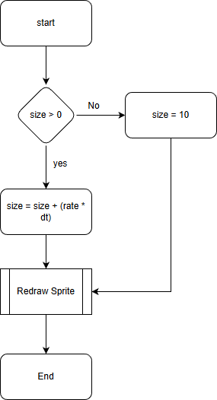
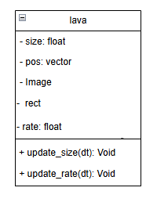
not feel like a smooth counions thing.
rate attribute: This is a multiplier for the size attribute which will increase with the passing of time as to speed up the growing of the lava sprite with time.

The update size method has two functions, it must increase the size of the sprite, and it must redraw the sprite after any changes have been made to it. The flowing flow chart shows how the update size method works:
The program starts by setting the size of the lava to 10. This is because initially, the size will be 0 always. The point of this is that the multiplier works quicker at the start of the game if it starts at 10 rather than at 0. The effect of adding itself to itself with the multiplier is much greater when it is a larger number than 0. 10 was chosen randomly and is subject to change based on stakeholder feedback. It is also important to note that this method will be constantly called in the main game loop. Therefore, at the next cycle, the size of the spite will be a non-zero number, and the multiplier will be applied. This is a standard multiplier based on the rate and time passing. The point of including dt is because it scales the rate of expansion with the frame rate of the game (dt is essentially the passing of time in the game from the pygame clock which is scaled to match the frame rate of the game, capped at 60). If I were not multiplying dt, the lava would so rapidly size as to be larger than the entire map in milliseconds as it is called thousands of times a second due to it being in the main game loop. Therefore, dt is essentially a mediator to stop the progression of time happening too quickly.2
The redraw sprite function, which is called at the end, however, is not dependent on dt. This is because if I redraw the sprite every game loop, the lava will appear to rise much smoother than if I scale it down. This will therefore lead to a smoother gameplay experience for the player. The downside of this is that it

could negatively impact the performance of the game as it needs to be redrawn every clock cycle. This should not be too much of a concern though because it is a simple red rectangle which should not be to arduous to draw and thus should not impede performance by much.
The update_rate() method is very similar to the update size method. A flow chat for this is shown below:
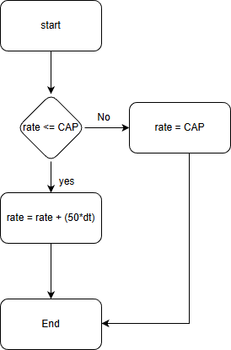
Once the program starts, this method will be run continuously within the main game loop. The method starts by checking if the rate is less than the maximum possible rate (CAP) as otherwise the lava would continuously exponentially increase to a point where it is impossible for the player to escape. The value of the cap will be determined by the players' difficulty setting, where the easy preset has a lower cap value than the medium and subsequentially the hard. The ability to change the value of the cap variable IS A USIABLITY FEATURE. This is because some players will find the game too difficult on the hard setting and get frustrated and stop playing. The same can be said about different players with the easy setting, where they find it too easy and to get bored. Therefore, the ability to adjust the cap value will make the game feel easier or harder dependent on the players' preference.
The rate will increase linearly with time until the cap is met at which point it will stop increasing. This growth can be molded as a line
graph of growth rate in pixels/second against time in seconds, shown below for the first 10 seconds. This model assumes a constant frame rate of 60 fps, a max rate of 250 pixels/second, and an initial rate of 10 pixels/second.

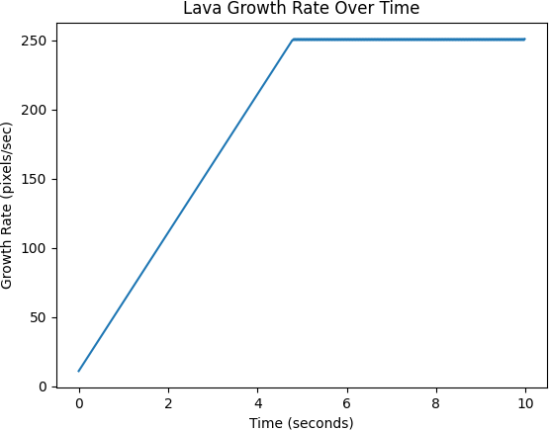

As you can see from this graph, there is an initial linear growth rate until the cap of 250 pixels/second is met at ruffly 5 seconds where it levels out for the reminder of the time.

Using this model, the graph below was produced with the same parameters to show the size of the lava sprite with time for the first 10 seconds. The gradient of the graph is proportional to the growth rate in the graph shown below. Therefore, as the growth rate increases for the first 5 seconds, the first part of the graph of lava height against time will be exponential. Then once the cap growth rate is met, the

height of the sprite will increase at a constant linear rate as the gradient of the graph is constant.
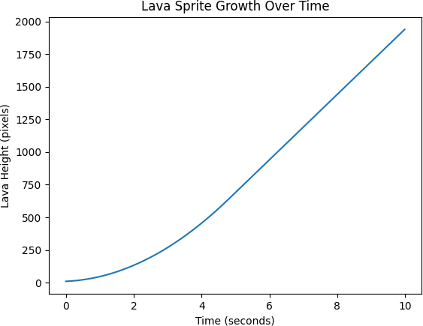

KEY VARIABLES FOR PROCEDURAL GENERATION

Name | Datatype | Scope | Purpose
Map_file | String | Global scope declared in load_map file | Stroes the directory location of the map.tmx file which stores the data for the map. This is used so that if I change the directory of the file at any given point, I only need to change the value of this string to the new location instead of having the change loads throughout  the whole program.
Tmx_data | Object, specifically: pytmx.pytmx.TiledMap | Global scope declared in load_map file | This stores an object that has all the tmx data and map attributes in one location for ease of use and  further extraction.
Map_data | Object, specifically: pyscroll.data.TiledMapData | Global scope declared in load_map file | This is an extraction of the tmx_data and stores only the map data where tmx_data stores information about both the map data and information about the tile set used, such as tile width and height ect. Map_data is thus used fully when handling the  map.
Map_layer | Object, specifically: pyscroll.orthographic.BufferedRenderer | Global scope declared in load_map file | A further extraction of TMX_data coming from a subsequent extraction of map_data to store information about only the layer tiles and not the entire map which consists of layer tiles and  object tiles.

group | Object, specifically: pyscroll.group.PyscrollGroup | Global scope declared in load_map file | This is the most important variable of the whole section and arguably the whole game. It is a group of sprites, including all the tile layers and object layers, which can be drawn all at once and updated all at once. This negates the need to update every individual sprite manually within the game loop. Moreover, it gives every sprite a relative position within the map using Pygame vectors instead of screen coordinates. This makes playing sprites and moving sprites throughout the map easy as everything is done relative to the  camera.
Collision_rects | Array | Local Scope of collision detection functsion | This will store an array of all the wall_rects, coin rects or spike rects that will be in the game dependent on the parameters of the function. This is necessary so that it can be iterated through for the player to be able to collide with map  tiles/objects.
Wall_rects | Array | Global scope declared in main script | A direct result from the variable above when running the function for the wall_layer as the parameter. This is used for the player  to know where on

the map the walls
are located.
Spike_rects | Array | Global scope declared in main script | A direct result from the variable above when running the function for the spike_layer as the parameter. This is used for the player to know where on  the map the walls are located.
Coin_rects | Array | Global scope declared in main script | A direct result from the variable above when running the function for the coin_layer as the parameter. This is used for the player to know where on the map the walls are located.
Coin | Object, specifically: handle_coin_logic.Coin | Global scope declared in main script | An object created from the coin class for every coin rect. This is then added to the pyscroll group to be drawn on the screen as a  sprite.
Lava | Object, specifically: lava_sprite.Lava | Global scope declared in main script | Object created from the lava class which  models the rising lava.
Growth_rate_cap | Integer | Global scope declared in main script | This will be the value of the largest growth rate that is determined by the  players chosen difficulty setting.

TEST PLANS FOR PROCEDURAL GENERATION

Feature/Subroutine | How to test it | Expected outcome | Justification
Random selection of supplementary level segments from the segment bank. | Run the game multiple times on the same difficulty setting and record the order of segments generated in each zone. Compare the segment sequences  across runs. | Each playthrough produces a different ordering of segments, with no fixed or repeating pattern. | This confirms that the procedural generation system successfully creates the illusion of randomness, which is a core design goal of the game and increases  replay ability.
Number of segments per zone dependent on difficulty preset. | Set the game difficulty to Easy, Medium, and Hard respectively, then count the number of segments loaded into a single zone using debug output or visual  inspection. | Easy should load 3 segments  Medium should load 5 segments  Hard should load 7 segments | This verifies that the difficulty scaler correctly affects zone length and overall challenge, ensuring balanced gameplay progression.
Correct placement of the spawn segment. | Start the game repeatedly and observe the first segment loaded in each zone.  Check that the player always spawns on the  spawn segment. | The spawn segment is always the first segment in every generated zone, and the player spawns at the correct location. | A consistent spawn location is essential for usability and prevents the player from spawning inside walls or hazards.
Vertical stitching of segments to form a continuous zone. | Play through multiple zones and observe transitions between segments, ensuring the player can always move from one  segment to the next. | All segments connect seamlessly with no blocked paths, gaps, or impossible transitions. | Ensures that all segments meet the design constraint of having open top and bottom rows to guaranteeing at least  one completable path.
Transition segment existing between zones | Reach the end of a zone and observe whether a transition segment appears while the next zone loads. | The transition segment loads smoothly; the player continues moving without interruption, and the next zone loads  successfully. | Prevents visible loading delays and maintains the illusion of infinite upward movement, improving user experience.
Only one zone loads at a time | Use debug logging or performance monitoring to check  memory usage before | Previous zones are unloaded when a new zone is generated, and | This confirms that procedural generation is implemented  efficiently and does not

 | and after transitioning  to a new zone. | memory usage remains  stable. | overload the processor  or memory.
Generation and storage of wall collision rects and spike collision rects. | Enable debug rendering of collision rects and verify that wall and spike collisions only occur where wall tiles exist in the currently loaded  segment. | The player collides correctly with walls and spikes in the active segment and does not collide with walls or spikes from unloaded segments. | Prevents “phantom collisions” and confirms that collision rects are correctly catalogued per segment.
Coin collision and sprite removal. | Collect a coin and observe whether it disappears and increments the score. | The coin is removed from the sprite group, and the score increases by one. | Validates collision detection logic and confirms correct interaction between procedural objects and  player mechanics.
Spawn tile location extraction from TMX object layers. | Move the spawn time within tiled software to different positions on the map. | The player spawns at the new spawn tile location without any code changes. | Confirms that the player starts the game where the spawn tile is places
Delayed lava start after player input. | Start the game and do not move the player, then observe lava  behavior. | The lava does not rise until the player provides their first  input. | Prevents unfair early deaths and improves game usability.
Lava growth rate and scaling cap | Play on different difficulty settings and record lava speed over time. | Lava speed increases over time but stops accelerating once the cap for that difficulty is  reached. | Ensures the game remains challenging but not impossible, maintaining fairness.

Section C. Developing the coded solution (“The development story”)
The order in which I explain the implementations generally reflects the sequence in which each solution was coded. However, this may not always be the case, as I used concurrent development to streamline the process. This meant that certain aspects of the game were developed simultaneously rather than strictly one after the other. Since a linear model cannot easily illustrate this overlap, the timeline of development may not always align perfectly with the order in which I present the solutions.

MENU SYSTEM

In this section I illustrate how I implemented the menu system following the outline defined in the section labeled “Overall button class and functionality.”

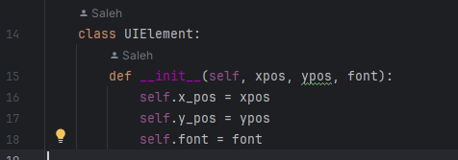
SUPER CLASS

To start, I created the super class “UIElement” with the attributes xpos, ypos and font but with no methods. These included attributes differ from the ones outlined in UML diagram as I found that including width and height would have been redundant as they would have been changed instantly. However, I chose to add the attribute font as it is a constant that is used for all buttons and labels and would have been redundant to put in every single instantiation. However, there is still the possibility to

change it via polymorphism if I need a label or button with a different font later. In addition, I removed both methods for this class, “draw() and update()” for very similar reasons, they are too different per sub-class to be included in a superclass and thus including them would have, again, been redundant and a drain on system memory as each object will required a different set of rules when being rendered.
Above shows a screenshot of this class.

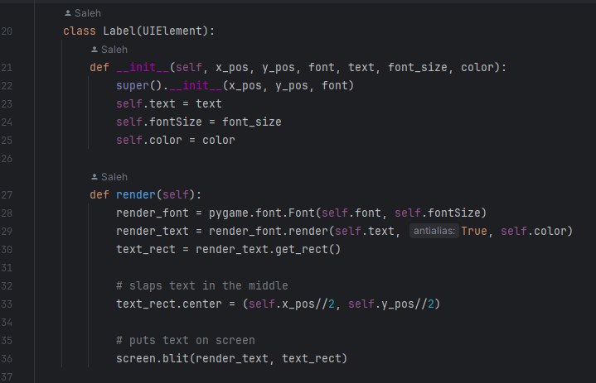
LABELS

Next is the label class which inherits the attributes: x_pos, y_pos and font from the “UIElement” class explained above. Also included in the constructor are the attributes text, font_size and color which all define how the label will look on the screen once instantiated.
The render method does just that: oversees the rendering of that specific label when called. In line 28,
the font is being established based on the attribute “font” inherited from the superclass UIElements. The text is then rendered/ loaded into the variable render_text using the font defined above in line 29 but this is not put onto the screen until line 36 where it is blit on the screen along with the rect.
Text_rect define the rectangular area around which the text will inhabit on the screen. This is not so important for text (other than telling the program to place the text on the screen) but will become very important when handling the collisions between entities later.

Typically, in pygame, the rect of an object is taken from the lower left corner of the object; the center of the object must therefore also be defined so when drawing it onto the screen it becomes easier to manage where to place it. That is what is being done in line 36 using integer division to calculate the center of the object. See the screenshot for this class below.

To create a label, I use the constructor shown below. This code is exicuted in the createMenuObjects script and is kept separate from the GUI classes for maintainability.
This constructor creates a label with the following attributes:
x.pos = 1290 (the point of the 1280/2 is to center it initially then move it left or right by a given amount relative to how to other labels and buttons on the menu)
y.pos = 150
Font = “grand9k pixels” - which is the font used for most of the lables and buttons as it fits the retro arcade style of the game
Text = “tomb of the Mask” - This is the main title screen Font_size = 100
Color = yellow
Overall, this creates a large label that is in the middle of the screen.
It is important to note that this object is created then instantly added to the menu “main_menu” via the
method add_element, which will be discussed in more detail in the menu section. This is a screen shot of what the label creates when it is rendered on the screen.


BUTTONS
The next class is the Button class. The instiller for this class is shown below.

Figure 1

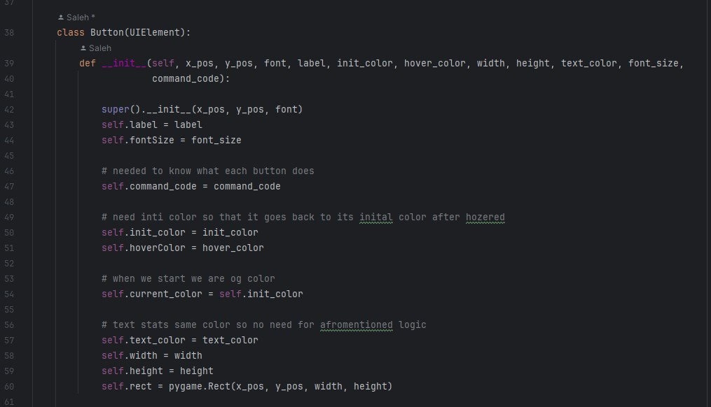
To explain this class, it is helpful to first understand everything that a button must do. The button must, and most importantly, process a specific command that is labeled by the button. For example: the exit button must quit the program to do this, the button thus must also have a title that details exactly what it does. It must also change color when the user's mouse is over the button and then return to that same color when the user moves their mouse. The constructor shown below in Figure 2 takes the fallowing attributes to allow each object to perform these functionalities.

Figure 2
X_pos, Y_pos and font are inherited from the class UIElements explained above for modularity and reduction of redundancy.

RENDERING
The attribute label tells the program what text to put on top of the button. This can be, for example, Start, Leaderboard, or Exit. This text is then rendered on top of a rectangle of width = width and height =

height (data from constructor – unique per object) and is done in the render method of the class shown below in F3:

Figure 3
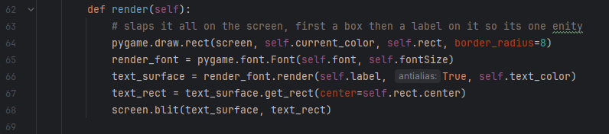
In line 64 a rectangle is drawn onto the screen, where self.rect is defined in the initializer as shown below in figure 4. This defines the dimensions and starting position of the rectangle on the screen as the button does not move, these are fixed values. It is worth mentioning that the parameter
“border_radius” for the inbuilt pygame rect dictates the level of curvature the rectangle has around the edges. Passing this parameter by values (of value 8) denotes a constant curvature of the button.

Figure 4
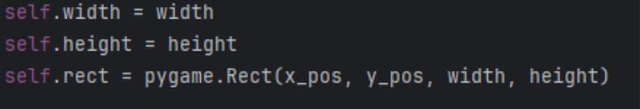

Next in line 65 (referring to figure 3) the font is prepared using the inbuilt python function font.Font which creates a font object stored under the variable render_font effectively preparing it to be rendered. This object is then rendered onto the screen using the pygame function render in line 66, this takes the parameter self.label, which, as aforementioned denotes the text to be put onto the button.
The text is then given a rect in line 67 which tells pygame the space inhabited by the text on the screen. Finaly, in line 68, the text is blit onto the screen on top of the previously drawn rectangle, thus concluding the explanation of this function.

HOVERING
There are three variables associated with the color of the button:

. Init_color – Attribute of the object passed through initializer telling the object the color it should be when not being hovered.
. HoverColor – Attribute of the object passed through initializer. Telling the object the color it should be when the button is being hovered.
. Current_color – variable depending on the state of the object. This is needed to keep track of the color at any given time and so it can be rendered as that.
The button will switch between init_color and hoverColor (updating the value of current_color appropriately) depending on rather or not the button is being hovered following the logic shown below written in English:
If the button is being hovered, current color = hoverColor Else current color = init_color
The actual logic for this happens in the menu class which will be explained in more detail in the menu section of this sub section but for now this is focusing on the changing button color logic, so momentarily ignore the other irrelevant sections of the code below:
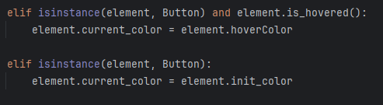
From this screenshot, “element” refers to an instance of the button class and in this therefore an individual button. Note how the method is_hovered() is called in the 1st line and 4th line before changing the color of the button in the subsequent lines following. This function of “element” will return true if the button is being hovered and false otherwise. Therefore, ignoring the irrelevant code, the program’s purpose is to check if the “element’s” method, is_hovered(), returns true and if it does set its current color to the hover color as the button is being hovered. Otherwise, the button is not being hovered over, so the elements' current color is sent to its initial color. This therefore also proves the necessity of the three distinct variables needed to represent the object’s color as, without the variable init_color, for example, the program would not know the original state of the button before it is hovered and therefore would not return to normal after being hovered.

The is_hovered() method is shown below:

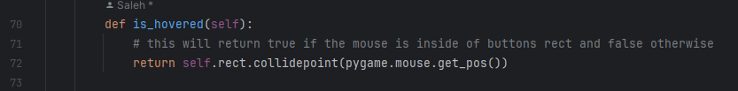
As mentioned above, this function will return either true or false. The inbuilt function .collidepoint() checks if a point is inside a rectangle. The point it is checking is the position of the mouse; this is found by using another inbuilt pygame function get_pos(). Therefore, if the mouse is determined to be inside the rectangle of the button, the function will return true, meaning that the button is being hovered.
Otherwise, it will return false, and the button will not hover.

CLICKING AND BUTTON FUNCTIONS

The most important part of the button is its ability to do something, and the first step to make a button do something is to determine whether it has been pressed or not. The logic to determine this is done in one function which is shown below:
This function will return true if the button is clicked and false otherwise. It takes the parameter event which passes as pygame.event.get(). This inbuilt pygame function returns an event object such as a key press, mouse button presses or exit event. The event that we are interested in in this case is a left mouse button click; we first gather that the button pressed is the mouse button indicated by the type being equal to pygame.MOUSEBUTTONDOWN. This yet another inbuilt pygame function is flagged when either mouse button is pressed down, yet it is not disambiguated from being the left mouse button or the right mouse button. As we want the left button, the next condition confirms as the left mouse button is given the flag 1. Now that we have identified that the left mouse button is being pressed, we must now confirm that the button itself is being pressed. Currently, if we were to negate the final condition, the button would act as if it were pressed if one were to click the mouse button anywhere.
This is not desirable as the button technically becomes the whole screen. To check that the button itself is pressed we call the function is_hovered() which, as explained above, hosts logic to determine that the button is being hovered over and this the mouse is over the button. Therefore, to summaries, the function will return true if the left mouse button is pressed and if the button is being hovered over. And false otherwise.
From here, the button knows that it's been pressed but does not yet know what it's meant to do now, which is an important part of the button. This is where the key attribute command_code comes into play. This attribute is a function call that is assigned to a button that calls a helper function which

processed the button's specific command. This is processed in the menu class in the handle_events method of the menu which is shown below:
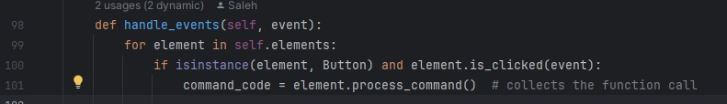
This code exists in the same handle_events method of the menu class and in fact in the same loop as the hovering logic, which was explained above. This is because they are both events that must be handled. The important part to focus on in the above code is in line 100 and 101, the rest will be explained in the menu class of this section. An element here represents an object that is associated with the Menu, in this case to take it to be a button, it then calls the particulars object’s is_clicked method which, as explained previously, returns true if the button is clicked and false otherwise by passing the parameter event which is handed by the pygame event handler.
From here, in line 101, a variable command_code is assigned to the currently being clicked element’s command by calling the element’s method process_command(). This method of the button class is a get method which simply returns the attribute command code, which is a function call.
To understand the next section of the code, because it becomes kind of weird from here, you must understand that every single button, as of yet, exists to change the menu from one state to another. For example, the leaderboard button changes the menu from the main menu to the leaderboard menu. To do this, it must unload the main menu and load the leaderboard menu. Therefore, the command for this must switch the main menu variable isloaded to false; the leaderboard menu variable isloaded to true and then the current menu to the leaderboard menu. This will be explained in more detail when I explain the menu classes. For now, know that every button will return a value for the new current menu relative to the menu it is meant to be loading, in the leader menu instance the current menu is now the leaderboard menu as shown below:
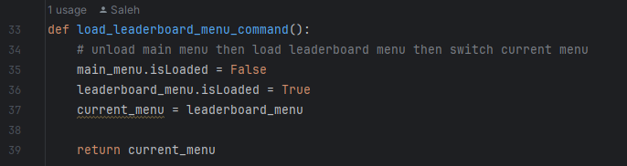
As you can see, the main_menu is being unloaded, the leaderboard menu is being loaded, and the current menu is switched to the leaderboard menu. It is important to note that every single button has a helper function like this one where it handles its appropriate menus in the same exact way; the outlier here of course being the back button, but more on that later.

Going back to the handle_events method in the menu class outlined above, you can see that when element.process_command() is run it will run the respective helper function for that button. The whole point of doing it this way is so that each button can be disambiguated in the event handler but also be grouped together and drawn all at the same time in the renderer, which is way more efficient. The handle events method then returns the command code, as shown below:
When this is returned, it runs the helper function which in turn returns the new value for the current menu.
Therefore, to summaries, when a button is clicked the program “collects” the command code, runs the associated helper function then returns the correct new current menu.

MENU CLASS AND STRUCTURE OF CODE
The point of having a menu is that all UI elements can be loaded and unloaded at the same time. This allows the program to easily keep track of which elements belong to which menu, and which should be loaded at a given time.
In essence, a menu object is an array of UI objects with methods to handle each object's specific needs.

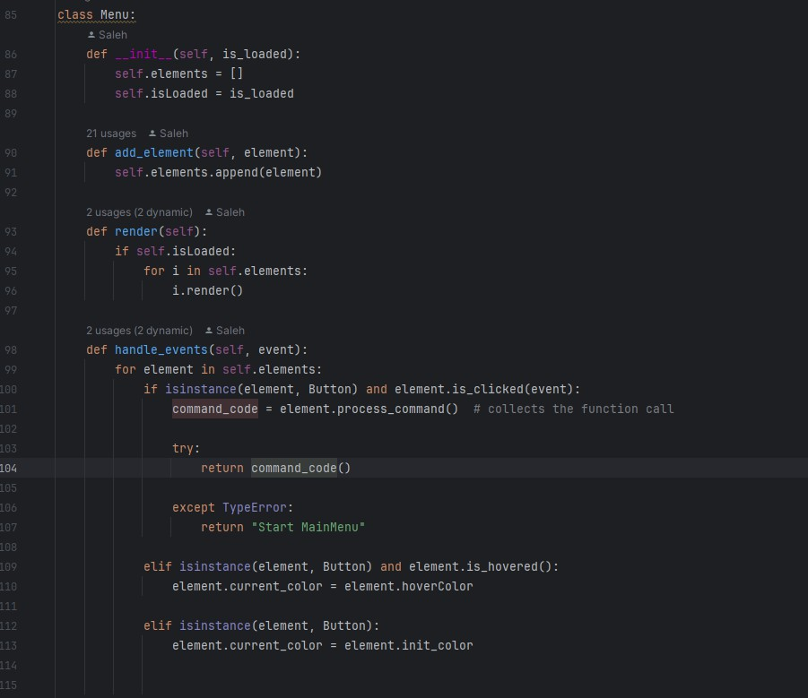
The whole menu class is shown below:

First, we have the initializer, where the key attribute is_loaded is assigned and passed by value. We also define the array of self.elements here, which is initially empty. This array will hold all the objects associated with that menu.
Next is the method, add_element. This method takes the parameter element which will be a label/button object and appends it to the list of elements established in the initializer.
Next is the render method. This is simply a for loop which iterates through elements and calls upon each object’s render method, which handles blitzing them individually onto the screen depending on their specific needs and attributes. Note line 94 where, before we render the whole list of elements, we check if the menu is loaded or not. This is a key bit of code that allows me to switch on and off each menu by simply changing one variable. If isloaded is true, that menu is loaded. Otherwise, it is not loaded.

Finaly is the handle_events method, the most important one. It is repeated below again for ease of explaining:
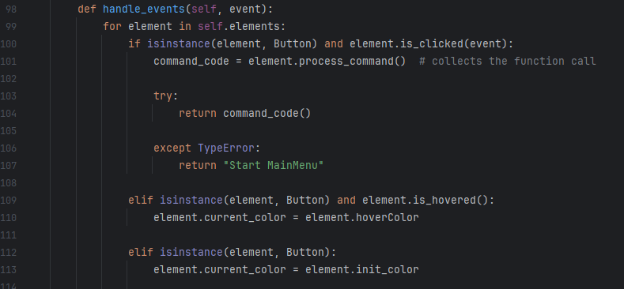
This method has already been explained in detail in previous sections of this document, but I think it is noteworthy to add that the for loop here is simply iterating thorough the array elements and checking if the element is a button in each instance of selection via the inbuilt method isinstance. This is because the only element that will have an event that needs procession will be a button, whether it be changing the color for hovering or processing its command when it is clicked, which was explained in the button section.

CREATING MENU OBJECTS AND UI OBJECTS AND TESTING BUTTONS

The creation of all the menu objects is done in the createMenuObject.py script upon first running the game. It would be more efficient however for me to save these pre-created objects in a JSON file, but that would be time consuming, and the current model works adequality, albeit draining processor power.
The constructors for the different menus are shown below:

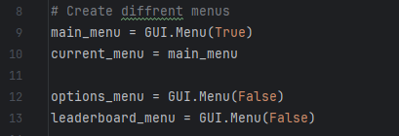
Shown is the constructor for the Main menu, which is initially set to be loaded, the option menu, which is set to not be loaded, and the leaderboard menu, which is also set to be not loaded. Also, is the declaration of the key variable current_menu, which, when the game is initially started, is set to be the main menu because this is the first menu that the players should be greeted with.
At this instance, all these menus have nothing in them; the elements array is empty. The main point of this script is to create all the objects of the UI elements for which they will be put into the respective menus. Before I list all the UI elements that will be in all of the menus and the respective helper function, it is important to note that all the constructors follow the game general format, where I define the xpos ypos font label ect.

MAIN MENU

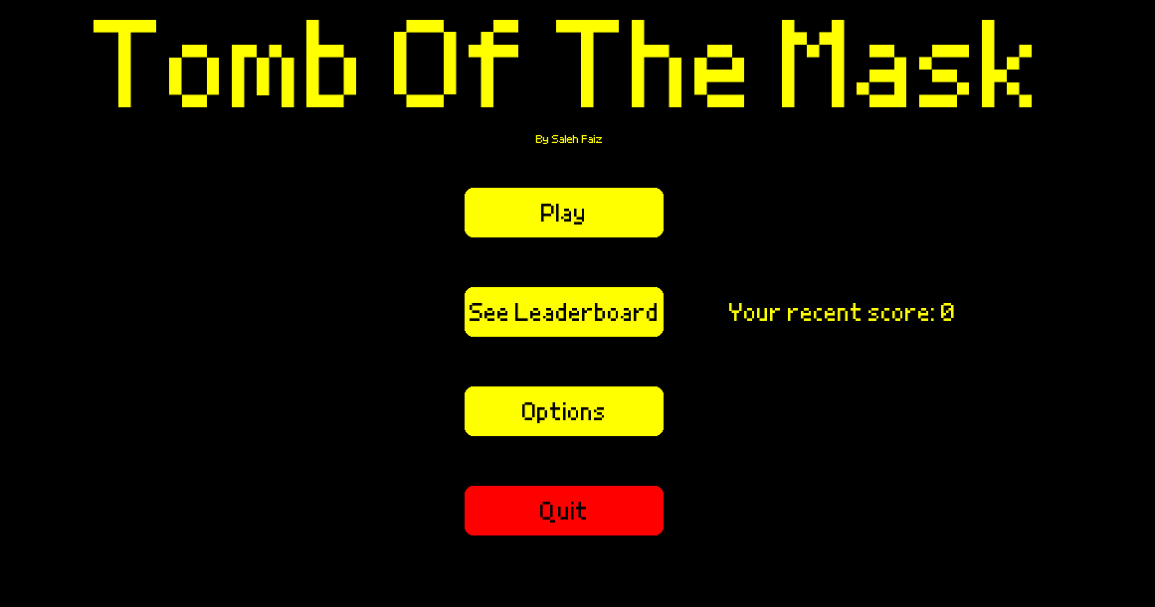

This screenshot shows the overall main menu appearance when the game is running. This is the first thing that the players will see when they run my game, and it is thus important for it to have a consistent theme and be aesthetically pleasing. This is why I have gone with consistent yellow buttons and text with retro style text. Each button and label declaration is explained and shown in more detail below; links to video testing the functionality of all the buttons following the test plans outlined in design are also given below.

Play button declaration:

Play button appearance in main menu:

does.

Play button command helper class:

Note that this is a notable button that will be at the center of the players' screen so that they easily know what to do to start the game. There is no ambiguity about what this button

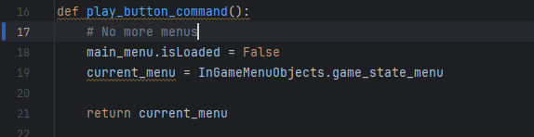
This helper class works in the same way as all the other helper classes, where the new current menu is being returned. Here, the main menu is being unloaded, and the game's state menu is being switched to the current menu. This menu will be blitzed on top of the game as the player plays.

Testing Play button
This test involves clicking the play button. As outlined in the design section, this should take the player to the game state screen. Currently, the game state screen is just a blank background with a pause button in the corner. The link provided below shows this:
https://www.youtube.com/watch?v=_7utFAbsODk
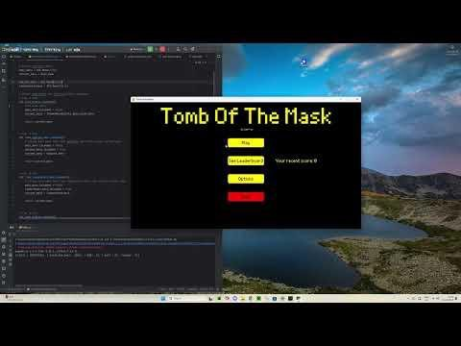

From this video, it can be concluded that the play button is sufficient and that it passes the test as it adequately loads the game state menu and unloads the main menu.

“By Saleh Faiz” label declaration

“By Saleh Faiz” label appearance in main menu:
Note that this is a small label that appears under large Tomb of the Mask welcome label which was explained as an example above.

Recent score label declaration:

Not here now the variable for recent score is being displayed; this will be collected from the database. The point of this is that the player can easily keep track of how they are doing.

Recent score label appearance in main menu:


See leaderboard button declaration:

This is assuming that the recent score variable is set to 0

See leaderboard button appearance in main menu:


See leaderboard button command helper class:
This command has been explained as part of an example in an earlier part of this document.

Testing See leaderboard button:
This test involves clicking the see leaderboard button. As outlined in the design section, this should take the player to the leaderboard menu. The rest of the leaderboard menu will be explained in detail in the leaderboard menu section. This link plays a video where the button testing is carried out:
https://youtu.be/XtbyN4KPHYQ



From this video, it can be concluded that the see leaderboard button is sufficient and that it passes the test as it adequately loads the leaderboard menu and unloads the main menu.

Options button declaration:

Options button appearance in main menu:


Options button command helper class:

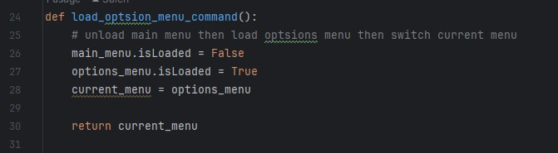
This function unloads the main menu, then loads the options menu, then sets the current menu to the options menu and returns this value.

Option button test
This test involves clicking the options button. As outlined in the design section, this should take the player to the options menu. Currently, the options menu is blank. In the future, there will be the ability to change the volume and difficulty of the procedural generation here. However, as their features are currently not in the game, there is no point in programming to change them yet. The link provided shows this test:
https://youtu.be/VXuxtQC3cq0
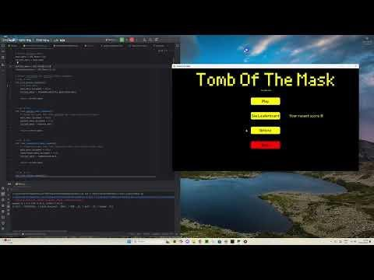

From this video, it can be concluded that the options button is sufficient and that it passes the test as it adequately loads the options menu and unloads the main menu.

Quit button declaration:
Note here how the command code is the inbuilt pygame function pygame.quit. This simply quits the game when it is clicked. The color of this button is also red instead of yellow. This is to fit with the theme.

Quit button appearance in main menu:


Testing Quit button
This test involves clicking the quit button. As outlined in the design section, this button should exit the game and stop the game loop. This can be seen happening as expected in this video, linked below:
https://youtu.be/dp5n9HMyvmc

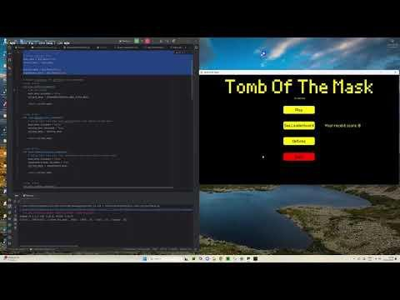

BUG WITH CHANGING BETWEEN IN GAME PAUSE MENU AND MAIN MENU
The try, except error handler from line 103 to 107 in the event handler method, is a neat work around for a bug I was having when switching between loading the in-game menu and the main menus.
Normally, when there is no error, the program returns the current menu which is set to the new menu which it is switching to. But due to the way my code is structured, which admittable isn't the most efficient way of doing it, the in-game menu object declaration is done in a separate file to the main menu object detraction. This means that when I must interchange between the two circular importation occurs. In particular, when exiting between the pause menu and the main menu via the “Exit to main menu button.” To work around this, I designed an inelegant solution where the buttons command code is simply None. As shown below:

This will cause an error as a none-type is not callable, which the handle_events method tries to do when the button is clicked. Therefore, the exception statement is called which, instead of the method
returning the current menu, returns a string “Start MainMenu”. This is a place-holder string and could be anything, if the program is looking for it in the game loop. As when the main loop receives this, it knows the unload the in-game menu and load the main menu.

This section of the main game loop is shown below and is where the methods are called and the menu handling is done.
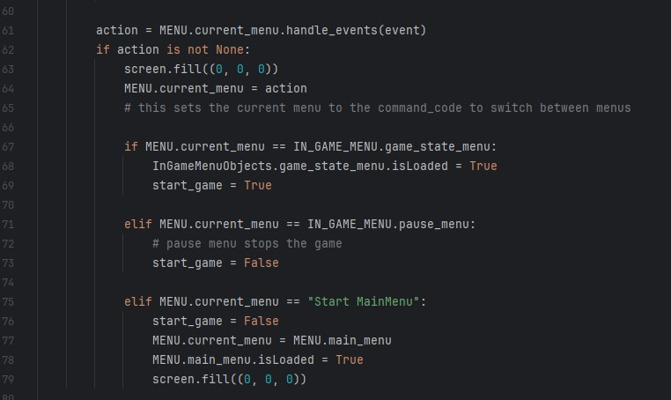
First, the program checks if there is a need for a menu change by calling the method “handle events” for the current menu. If a button is pressed in the current menu, action is set from None to the menu that is to be switched to by the appropriate helper function explained above. The current menu is then switched to this new menu in line 64. The screen must first be filled with black though in line 63 as to reset the screen as otherwise the two menus will be drawn on top of each other, as shown below if this line was not included in the program:

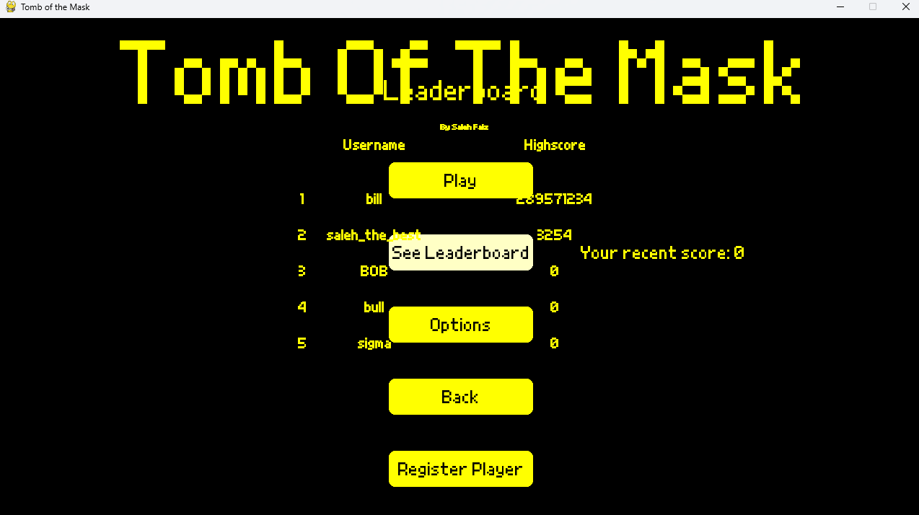
As you can see from the image above, the leaderboard menu is drawn on top of the main menu as the screen was never reset. This was a confusing bug because nothing is wrong with the code in this instance as the isloaded variables were changing correctly for the unloaded menus, and the main menus, in this instance, was not being rendered anymore, so why would it still be drawn? I believe it has to do with the way pygame updates the screen, and even though the unloaded menu is not being rendered any more, it is still drawn on the screen because it was never undrawn. Therefore, the solution was to add the screen. fill(0,0,0) line which fills the screen black before the new menu is drawn on top. This means that the previous menu is technically underneath this black canvas, but it is now being covered up, so out of sight out of mind. This should not cause too much lag as all the features of this menu, such as the constant button checking, are disabled as it is no longer being rendered and thus this checking stops.

DATABASE CONNECTION AND LEADERBOARD

I started by creating the SQL table that will be storing all the data from my MySQL workbench software, shown below.
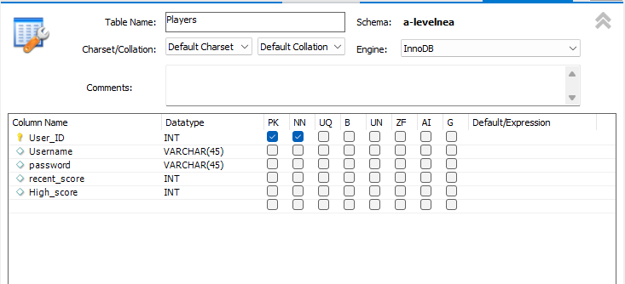
As you can see, I set the User_ID to the primary key and set it to not be Null (shown by the blue tick under the NN column). It mustn't be Null because otherwise there could be errors in some calculation performed with the user ID as you cannot divide by zero. It is unlikely that I would come across this, but it is better to have it set up this way now than going back and changing it in the future. This is also set to an integer datatype as the primary key must be an integer. Moreover, I set this field to autoincrement when a new record is added to the table. This will ensure that each new record has a unique primary key

as it will always be once more than the previous key. It will also make indexing far easier as each record will be stored sequentially instead of random order.
Both the username and password field are set to the VARCHAR (45) datatype, meaning that they can store a string of up to 45 characters. This means that there should be a feature preventing entry of a username or password for longer than 45 characters as trying to input that into the database would cause an error.
Both recent_score and High_score fields are set to the integer datatype. This is because the score a player gets will always be an integer and thus it is not worth setting it to a float.

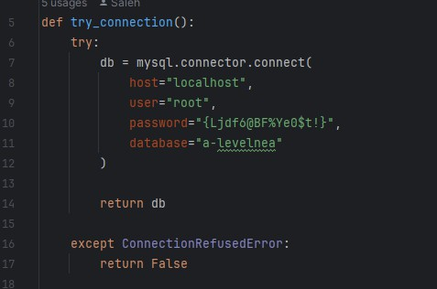
Next, I created the try_connectsion() function, shown above, in the handle_database script. This function will test the database connection and return a connection object (db) if a connection to the database hosted on my PC is established. It will return False otherwise. This is important because a connection will only be able to be established if it is running on my computer as the server is locally hosted and thus by running this function, which permeants the Connection Refused error, crashes due to poor connection can be mitigated and whole sections of code can be omitted which would otherwise require a db connection to run.
One of these functions is the collect_leaderboard_data function. This function oversees collecting all usernames and high scores for all the players in the database and returning them as a sorted array of tuples.
This function is shown below, in the handle_database script:

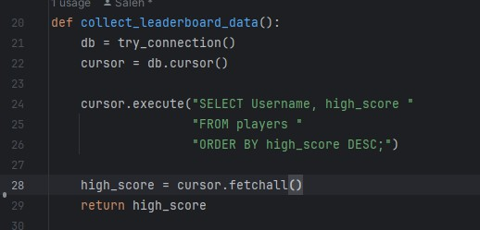

As you can see, in line 21, the db variable is assigned to the previously explained try_connectsion function which will always be a database object in this case because before it is called in the other scripts it is check that it is not false, otherwise, there would be an error and the program would crash.
In line 22, the cursor variable is created which is then used in line 24 to execute a line of SQL explained here in the design section of this document. It is important to understand that when a SQL statement is executed via the cursor, the python program doesn't automatically know the results of that command as it has been run in a separate SQL terminal. To access the results, the command cursor.fetchall() is used in line 28 which

MAP CREATION

PLAYER MECHANICS

BUG WITH GAME NOT RESTARTING UPON PLAYER DEATH

The issue I am having at the moment is that the game will not restart if the player dies or the player exists to main menu. It will simply pause the game and then when the player presses play again, it starts right back again where it left off. This can be shown to happen in this video:
https://youtu.be/FT5Xzjh9efo
In this video, I start the game and move the character out of the starting position then quite the game via the exit to main menu button in the pause game menu. This should restart the game and upon pressing play again in the main menu after quitting the player should start again at the spawn location. This however is not the case as shown by the video where the player starts exactly where they left off. This is clearly a huge bug and needs addressing. I believe the issue is that the game is never being restarted as I am loading all the game objects, such as the map, coins, players all at once in the beginning. This means that when I am quitting the game I am only exiting the game loop and never restarting the game objects. This can be seen happening in these lines of code below:
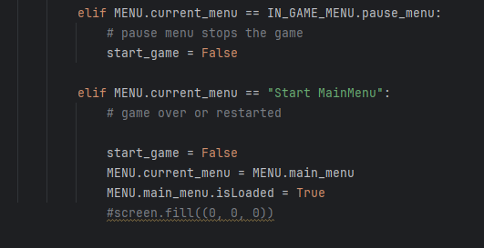
As you can see, the variable start_game is being set to False once the quite button is being hit. This then exits the game loop as the condition start_game must be true for the game to run. But as aforementioned just because the game loop is being exited doesn't mean the game objects are being restarted. Instead, there should be a function created where all the loading is done in there and then this is called when the game is to be restarted. This fix is shown below:

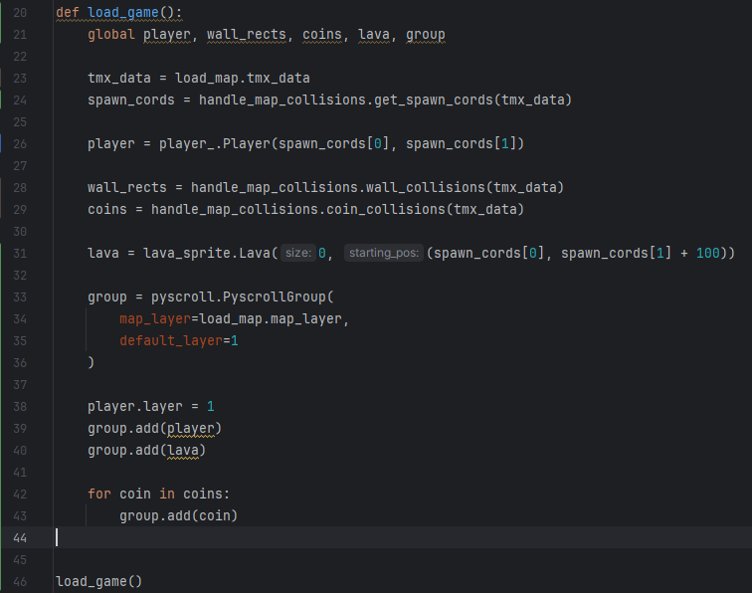
Here, you can see that I have created the function load_game() which initializes all the objects that are needed in the game and declares them as global variables so they can be used in the global scope of the program. The function is then run right away so that these variables can initially be used.
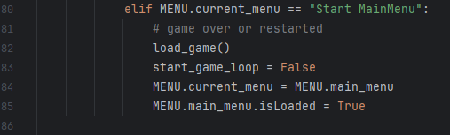
The next change I made was to call this function in this block of code, shown below:

This will in essence reload all the game state objects when the restart game button is pressed. This will also happen if the player is dead.

<See H446-03 Project Advice Booklet for help and guidance of what must go here.> Section D. Evaluation

<See H446-03 Project Advice Booklet for help and guidance of what must go here.>
]Project Appendixes
Insert as many project appendixes as you need for your project. These might include, but are not limited to:
- Complete Code Listing (ESSENTIAL)
- Interview Transcripts
- Meeting notes
- Observation notes or questionnaires

